ASSIGNMENT 2: CONSTRUCTION ACTIVITIES AND PROCESS

BUILDING CONSTRUCTION 1 (ARC 1523)

NAME: MOHD SHAHRUL IZZAT BIN ABDULLAH

STUDENT ID: 0317185

LECTURER: MR. BRUCE LEE XIA SHENG

**WEEK 1**

**CONSTRUCTION ACTIVITY:** Site Clearing and Earthwork

**DURATION:** 6 Days

**EQUIPMENTS:**

Machineries such as bulldozer, excavator, backhoe, roller truck.

Fencing material or boards according to size of site for site boundary, company placard, safety precautions signs, and tools.

**SKILLED WORKER:**

Civil Engineer, Ground engineer, Architect, site clearing supervisor, skilled machineries driver, experienced labors in site clearing process.

**TECHNICAL INFORMATION:**

* Provide the construction and completion of site clearance and earthwork around the site boundary comprising clearance of trees, shrubs, rubbish etc.
* Leveling cutting and filling to required platform level as Engineer’s requirement.
* Temporary works and other preparatory groundwork to achieve platform level and everything necessary and to move anything unnecessary materials debris etc.
* Meets the Architect’s satisfaction from the drawing and described in the specification.

**WEEK 2**

**CONSTRUCTION ACTIVITY:** Site Works,Installation of Temporary Facilities

**DURATION:** 3 Days

**EQUIPMENTS:** Tools, cabins, furniture.

**SKILLED WORKER:** Contractor, Labours, Site supervisor.

**TECHNICAL INFORMATION:**

* Provide hoarding or signboard
* Site office for consultant, contractor, meeting room, washroom
* Storage for materials such as cement, steel, sand, aggregate
* Provide access for loading and unloading
* Provide water supply
* Provide electricity

**CONSTRUCTION ACTIVITY:** Setting Out and Excavation

**DURATION:** 3 Days

**EQUIPMENTS:** Shovels, machineries such as excavator, backhoes, bulldozer

**SKILLED WORKER:** Experienced and skilled machineries drivers, site supervisor.

**TECHNICAL INFORMATION:**

* Establish a base line from which the whole building can be set out
* The position line is clearly marked on-site
* Digging the holes to place pile caps for foundations of the building.

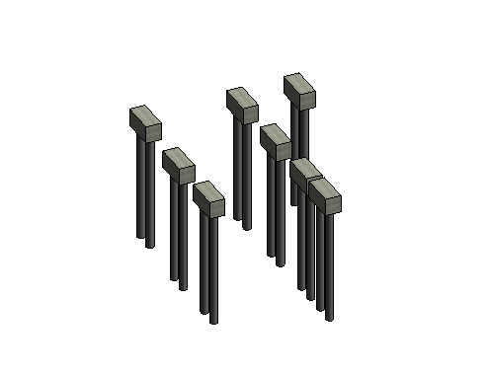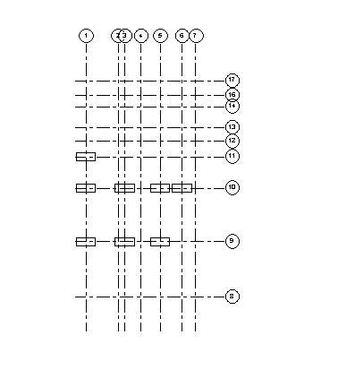

**WEEK 3**

**CONSTRUCTION ACTIVITY:** Piling 1

**DURATION:** 6 Days

**MATERIALS:** Reinforced concrete, timber formwork, pre-stressed tendon

**EQUIPMENTS:** Bar bending machine, table saw, pile driver

**SKILLED WORKER:**

General worker for bar bending process, labours, pile driving driver, carpenter for formwork process, site supervisor

**TECHNICAL INFORMATION:**

Reinforced concrete piles are driven into the ground using a pile driver. While doing this process, the carpenter will prepare the formwork and insert reinforcement bar with concrete grade 30 for pile caps. Piling is also important to ensure the quality of the work and to prevent crack when the formwork is left there for two weeks.

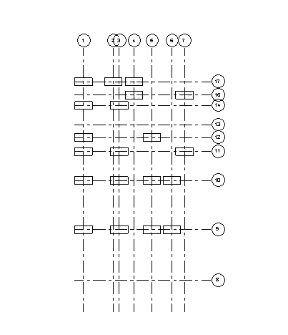

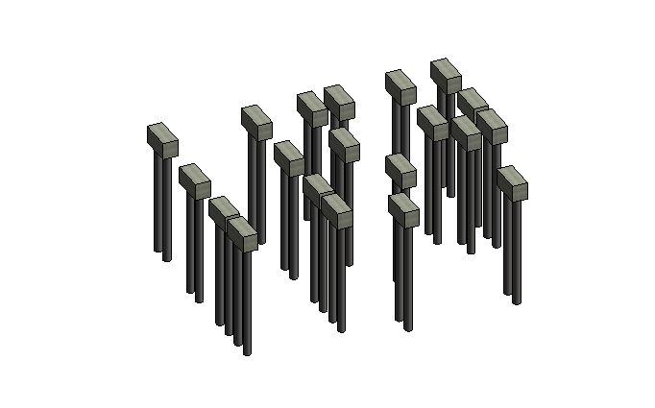

**WEEK 4**

**CONSTRUCTION ACTIVITY:** Piling 2

**DURATION:** 6 Days

**MATERIALS:** Reinforced concrete, timber formwork, pre-stressed tendon

**EQUIPMENTS:** Bar bending machine, table saw, pile driver, tools

**SKILLED WORKER:**

General worker for bar bending process, labours, pile driving driver, carpenter for formwork process, site supervisor

**TECHNICAL INFORMATION:**

Reinforced concrete piles are driven into the ground using a pile driver. While doing this process, the carpenter will prepare the formwork and insert reinforcement bar with concrete grade 30 for pile caps. Piling is also important to ensure the quality of the work and to prevent crack when the formwork is left there for two weeks.





**WEEK 5**

**CONSTRUCTION ACTIVITY:** Pile Capping 1

**DURATION:** 6 Days

**MATERIALS:** Reinforced concrete, timber formwork

**EQUIPMENTS:** Bar bending machine, tools, table saw

**SKILLED WORKER:** General workers, labours, site supervisor

**TECHNICAL INFORMATION:**

* The reinforcement bar with concrete grade 30 for pile caps is put on the site

**WEEK 6**

**CONSTRUCTION ACTIVITY:** Pile Capping 2

**DURATION:** 6 Days

**MATERIALS:** Reinforced concrete, timber formwork

**EQUIPMENTS:** Bar bending machine, tools, table saw

**SKILLED WORKER:** General workers, labours, site supervisor

**TECHNICAL INFORMATION:**

* The reinforcement bar with concrete grade 30 for pile caps is put on the site

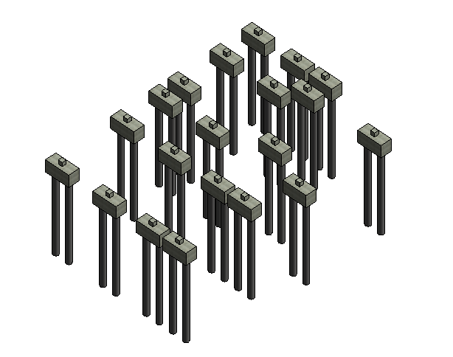

**WEEK 7**

**CONSTRUCTION ACTIVITY:** Stump from pile caps

**DURATION:** 6 Days

**MATERIALS:** Concrete grade 30, reinforcement bar, timber formwork

**EQUIPMENTS:** Bar bending machine, concrete vibrator, wood, tools.

**SKILLED WORKER:** Carpenters, general workers, labours

**TECHNICAL INFORMATION:**

* Stump is built to provide clearance for services such as plumbing and wiring. Stump is built on the slab.

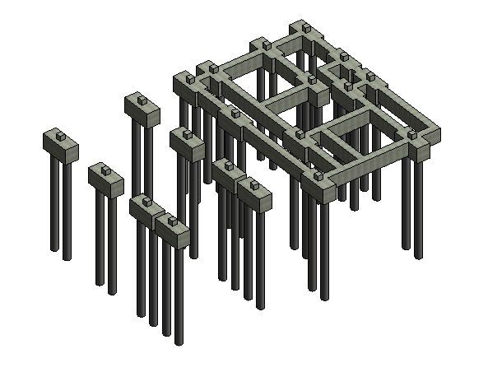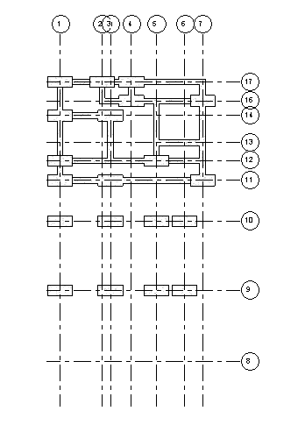

**WEEK 8**

**CONSTRUCTION ACTIVITY:** Ground Beam 1

**DURATION:** 6 Days

**MATERIALS:** Concrete grade 30, timber formwork, reinforcement bar.

**EQUIPMENTS:** bar bending machine, concrete vibrator, tools

**SKILLED WORKER:** Carpenters, general workers, labours

**TECHNICAL INFORMATION:**

* The stumps on the slabs are connected to the ground beam for further support of foundation

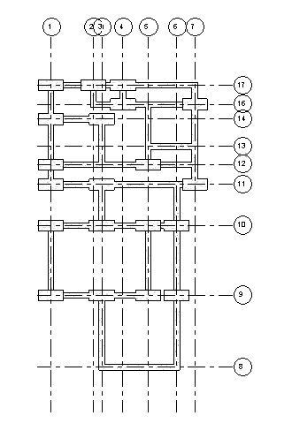

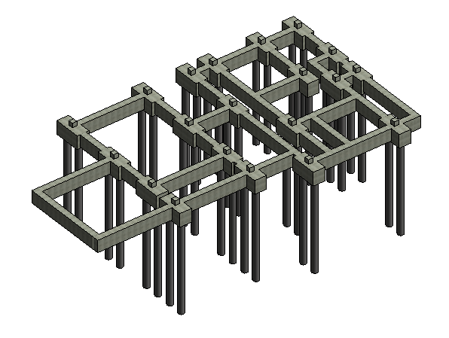

**WEEK 9**

**CONSTRUCTION ACTIVITY:** Ground Beam 2

**DURATION:** 6 Days

**MATERIALS:** Concrete grade 30, timber formwork, reinforcement bar.

**EQUIPMENTS:** bar bending machine, concrete vibrator, tools

**SKILLED WORKER:** Carpenters, general workers, labours

**TECHNICAL INFORMATION:**

* The stump is connected to the ground beam for further support of foundation

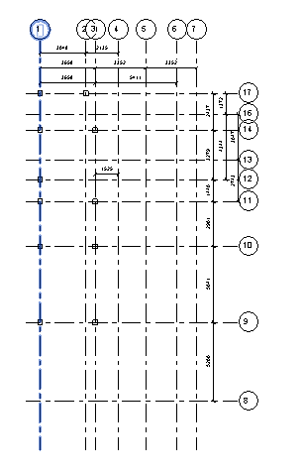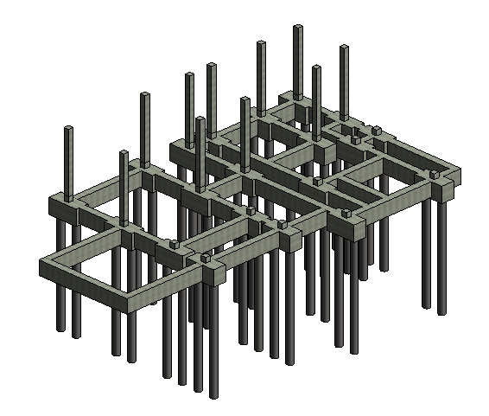

**WEEK 10**

**CONSTRUCTION ACTIVITY:** Ground Floor Columns 1

**DURATION:** 6 Days

**MATERIALS:** Concrete grade 30, timber formwork, reinforcement bar.

**EQUIPMENTS:** Bar bending machine, concrete vibrator, tools

**SKILLED WORKER:** Carpenters, general workers, labours

**TECHNICAL INFORMATION:**

* Column is built from the stump concrete of the foundation.
* Column is built as the structural framing of the house.

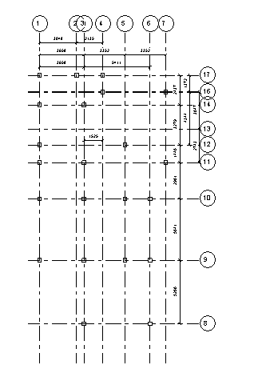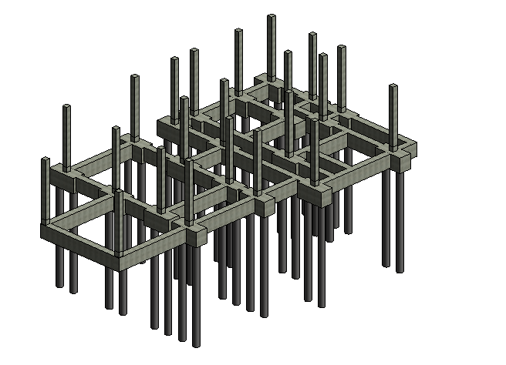

**WEEK 11**

**CONSTRUCTION ACTIVITY:** Ground Floor Columns 2

**DURATION:** 6 Days

**MATERIALS:** Concrete grade 30, timber formwork, reinforcement bar.

**EQUIPMENTS:** Bar bending machine, concrete vibrator, tools

**SKILLED WORKER:** Carpenters, general workers, labours

**TECHNICAL INFORMATION:**

* Column is built from the stump concrete of the foundation.
* Column is built as the structural framing of the house.

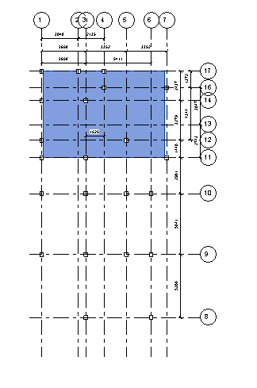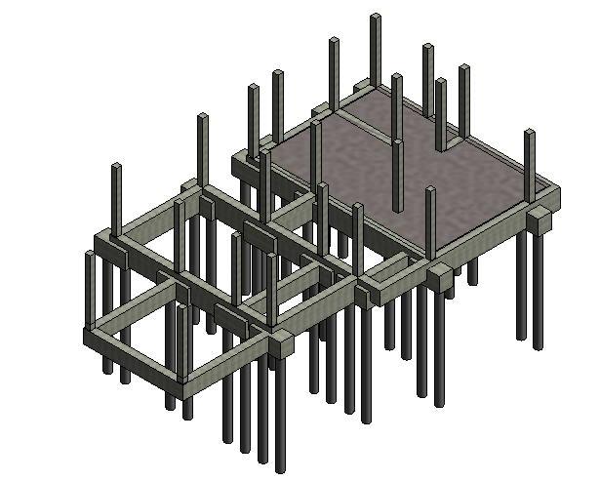

**WEEK 12**

**CONSTRUCTION ACTIVITY:** Ground Floor Slab 1

**DURATION:** 6 days

**MATERIALS:** Concrete grade 30 (generic 150mm), timber formwork, reinforcement bar.

**EQUIPMENTS:** Bar bending machine, concrete vibrator, tools.

**SKILLED WORKER:** Carpenters, General workers, Labours

**TECHNICAL INFORMATION:**

* Concrete is poured into the ground beams frame to create the ground floor.

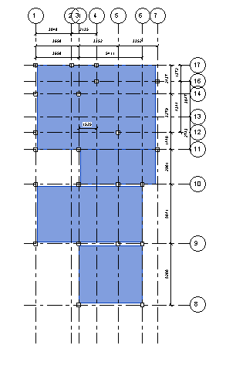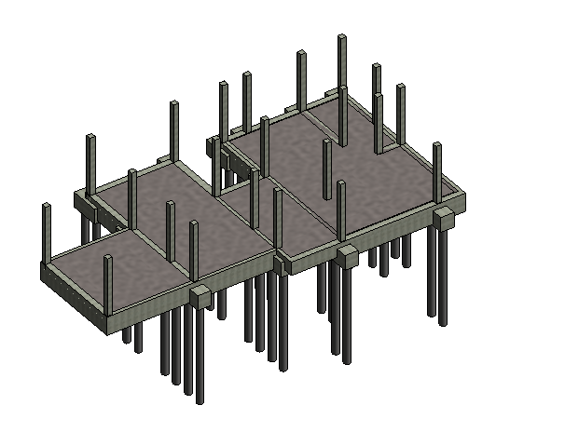

**WEEK 13**

**CONSTRUCTION ACTIVITY:** Ground Floor Slab 2

**DURATION:** 6 days

**MATERIALS:** Concrete grade 30 (generic 150mm), timber formwork, reinforcement bar.

**EQUIPMENTS:** Bar bending machine, concrete vibrator, tools.

**SKILLED WORKER:** Carpenters, General workers, Labours

**TECHNICAL INFORMATION:**

* Concrete is poured into the ground beams frame to create the ground floor.

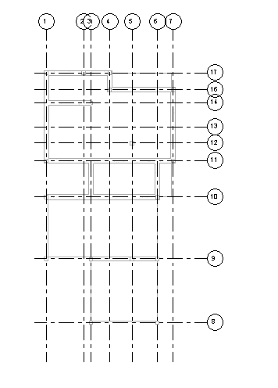

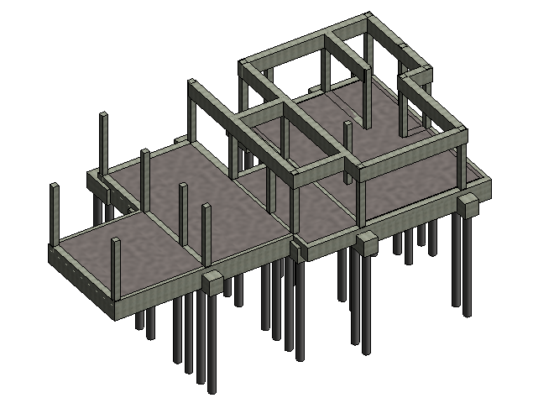

**WEEK 14**

**CONSTRUCTION ACTIVITY:** First Floor Beam 1

**DURATION:** 6 Days

**MATERIALS:** Concrete grade 30, timber formwork, reinforcement.

**EQUIPMENTS:** Bar bending machine, concrete vibrator, tools, scaffolding, steel trowel

**SKILLED WORKER:** Carpenters, General workers, Labours

**TECHNICAL INFORMATION:**

* The construction of beams for the first floor is continued by connecting the columns to increase stabilization.

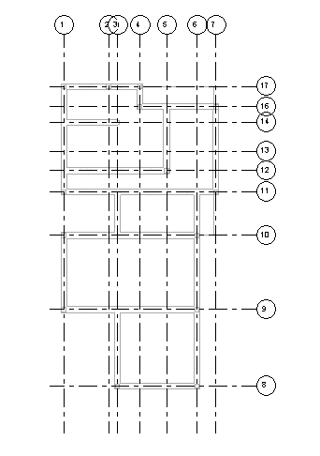

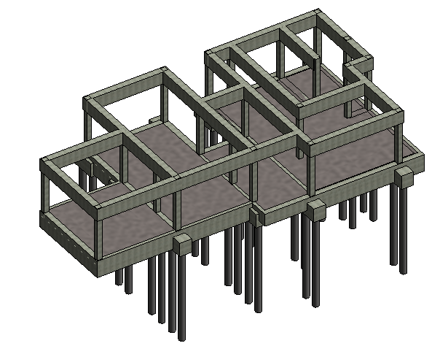

**WEEK 15**

**CONSTRUCTION ACTIVITY:** First Floor Beam 2

**DURATION:** 6 Days

**MATERIALS:** Concrete grade 30, timber formwork, reinforcement.

**EQUIPMENTS:** Bar bending machine, concrete vibrator, tools, scaffolding, steel trowel

**SKILLED WORKER:** Carpenters, General workers, Labours

**TECHNICAL INFORMATION:**

* The construction of beams for the first floor is continued by connecting the columns to increase stabilization.

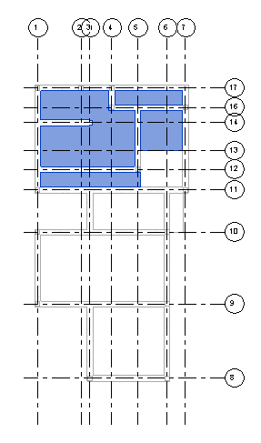

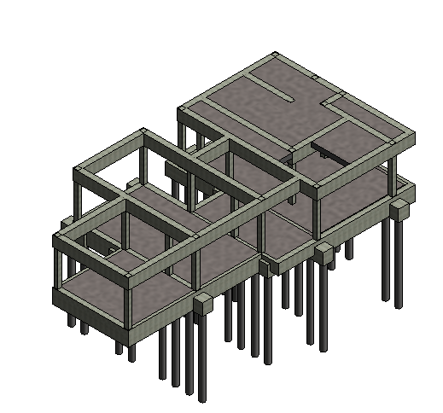

**WEEK 16**

**CONSTRUCTION ACTIVITY:** First Floor Slab 1

**DURATION:** 6 Days

**MATERIALS:** Concrete grade 30, timber formwork, reinforcement.

**EQUIPMENTS:** Bar bending machine, concrete vibrator, tools, scaffolding, steel trowel

**SKILLED WORKER:** Carpenters, General workers, Labours.

**TECHNICAL INFORMATION:**

* Concrete is poured into the frame work made around the first floor beams frame to create the first floor.

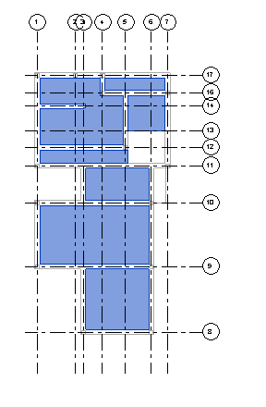

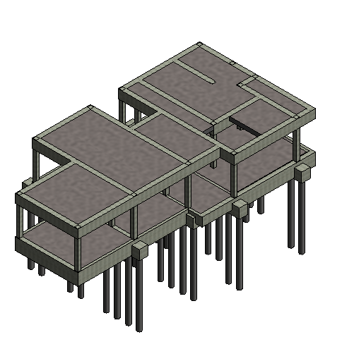

**WEEK 17**

**CONSTRUCTION ACTIVITY:** First Floor Slab 2

**DURATION:** 6 Days

**MATERIALS:** Concrete grade 30, timber formwork, reinforcement.

**EQUIPMENTS:** Bar bending machine, concrete vibrator, tools, scaffolding, steel trowel

**SKILLED WORKER:** Carpenters, General workers, Labours.

**TECHNICAL INFORMATION:**

• Concrete is poured into the frame work made around the first floor beams frame to create the first floor.

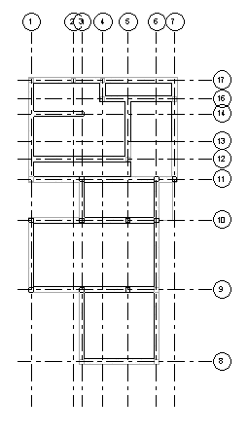

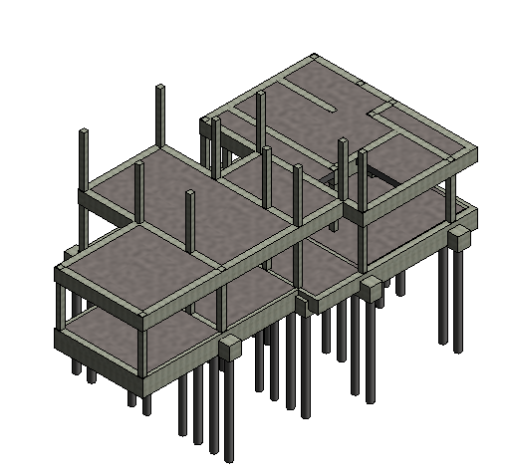

**WEEK 18**

**CONSTRUCTION ACTIVITY:** First Floor Columns 1

**DURATION:** 6 Days

**MATERIALS:** Concrete grade 30, timber formwork, reinforcement.

**EQUIPMENTS:** Bar bending machine, concrete vibrator, tools, scaffolding, steel trowel

**SKILLED WORKER:** Carpenters, General workers, Labours.

**TECHNICAL INFORMATION:**

* Column is built from the column built at the ground floor.
* Column is built as the structural framing of the house for the first floor.

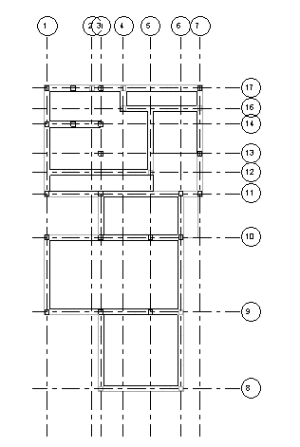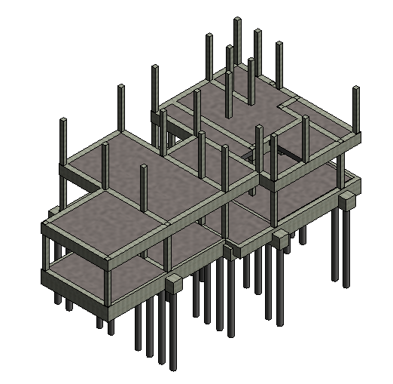

**WEEK 19**

**CONSTRUCTION ACTIVITY:** First Floor Columns 2

**DURATION:** 6 Days

**MATERIALS:** Concrete grade 30, timber formwork, reinforcement.

**EQUIPMENTS:** Bar bending machine, concrete vibrator, tools, scaffolding, steel trowel

**SKILLED WORKER:** Carpenters, General workers, Labours.

**TECHNICAL INFORMATION:**

* Column is built from the column built at the ground floor.
* Column is built as the structural framing of the house for the first floor.

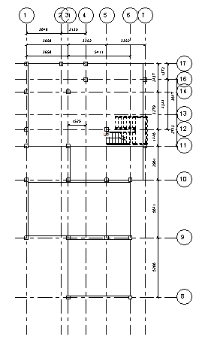

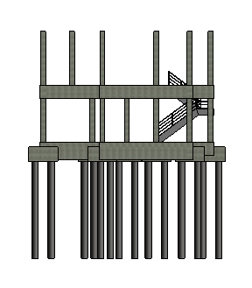

**WEEK 20**

**CONSTRUCTION ACTIVITY:** Stairs to the First Floor

**DURATION:** 6 Days

**MATERIALS:** Concrete grade 30, timber formwork, reinforcement.

**EQUIPMENTS:** Bar bending machine, concrete vibrator, tools, scaffolding, steel trowel

**SKILLED WORKER:** Carpenters, General workers, Labours

**TECHNICAL INFORMATION:**

* The staircase is built to connect the ground floor to the first floor.

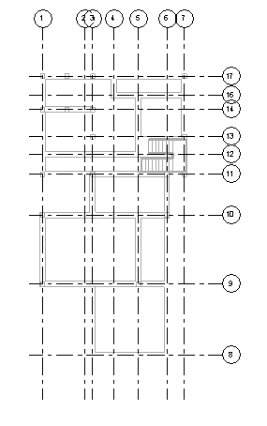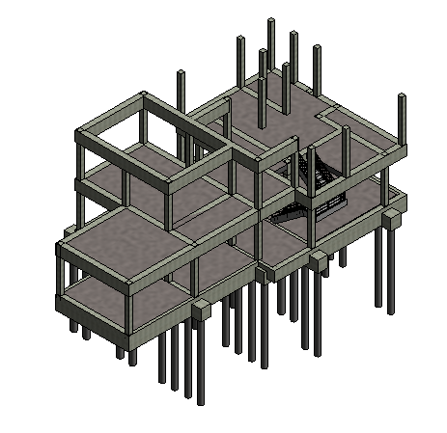

**WEEK 21**

**CONSTRUCTION ACTIVITY:** Second Floor Beam 1

**DURATION:** 6 Days

**MATERIALS:** Concrete grade 30, timber formwork, reinforcement.

**EQUIPMENTS:** Bar bending machine, concrete vibrator, tools, scaffolding, steel trowel

**SKILLED WORKER:** Carpenters, General workers, Labours

**TECHNICAL INFORMATION:**

* The beam construction is continued to the second floor by connecting the structural column of the first floor.

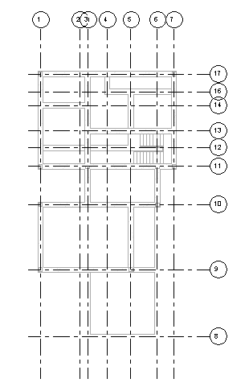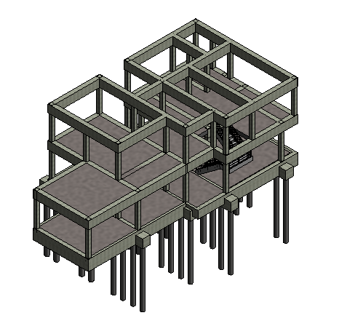

**WEEK 22**

**CONSTRUCTION ACTIVITY:** Second Floor Beam 2

**DURATION:** 6 Days

**MATERIALS:** Concrete grade 30, timber formwork, reinforcement.

**EQUIPMENTS:** Bar bending machine, concrete vibrator, tools, scaffolding, steel trowel

**SKILLED WORKER:** Carpenters, General workers, Labours

**TECHNICAL INFORMATION:**

* The beam construction is continued to the second floor by connecting the structural column of the first floor.

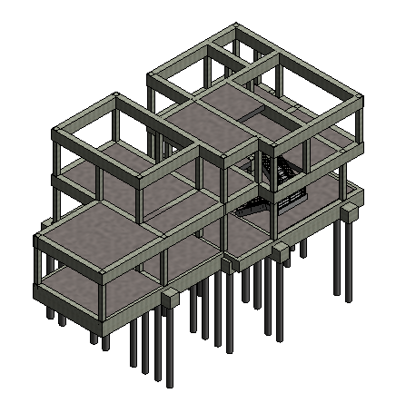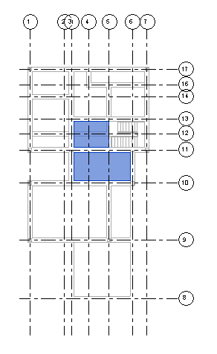

**WEEK 23**

**CONSTRUCTION ACTIVITY:** Second Floor Slab 1

**DURATION:** 6 Days

**MATERIALS:** Concrete grade 30, timber formwork, reinforcement.

**EQUIPMENTS:** Bar bending machine, concrete vibrator, tools, scaffolding, steel trowel

**SKILLED WORKER:** Carpenters, General workers, Labours.

**TECHNICAL INFORMATION:**

• Concrete is poured into the frame work made around the second floor beams frame to create the second floor.

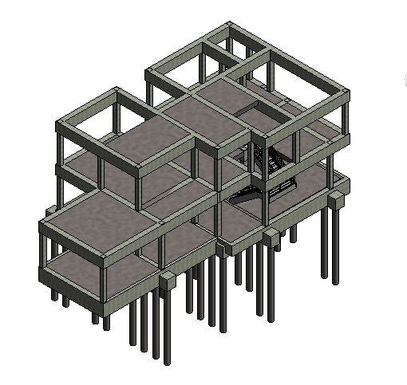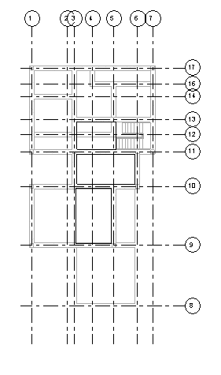

**WEEK 24**

**CONSTRUCTION ACTIVITY:** Second Floor Slab 2

**DURATION:** 6 Days

**MATERIALS:** Concrete grade 30, timber formwork, reinforcement.

**EQUIPMENTS:** Bar bending machine, concrete vibrator, tools, scaffolding, steel trowel

**SKILLED WORKER:** Carpenters, General workers, Labours.

**TECHNICAL INFORMATION:**

• Concrete is poured into the frame work made around the second floor beams frame to create the second floor.

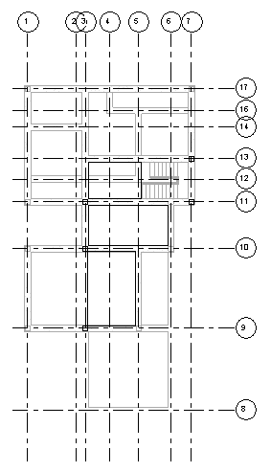

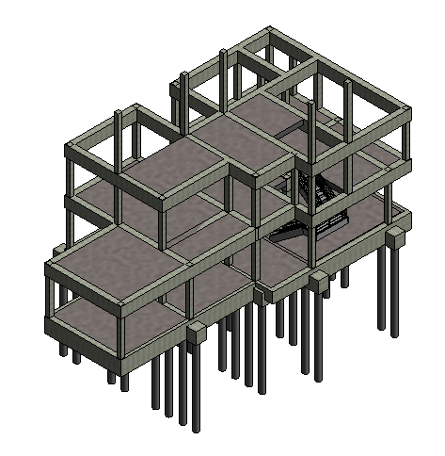

**WEEK 25**

**CONSTRUCTION ACTIVITY:** Second Floor Columns 1

**DURATION:** 6 Days

**MATERIALS:** Concrete grade 30, timber formwork, reinforcement.

**EQUIPMENTS:** Bar bending machine, concrete vibrator, tools, scaffolding, steel trowel

**SKILLED WORKER:** Carpenters, General workers, Labours.

**TECHNICAL INFORMATION:**

* Column is built from the column built at the first floor.
* Column is built as the structural framing of the house for the second floor.

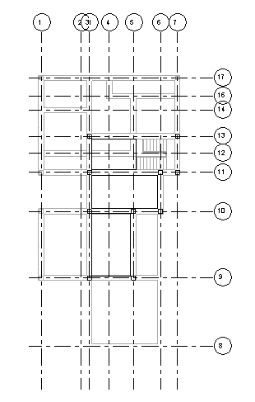

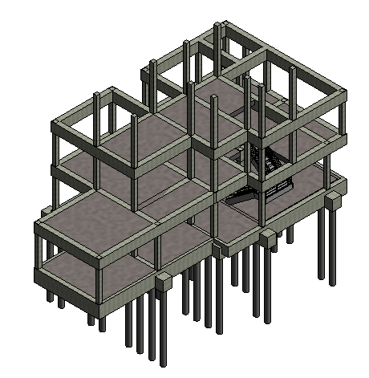

**WEEK 26**

**CONSTRUCTION ACTIVITY:** Second Floor Columns 2

**DURATION:** 6 Days

**MATERIALS:** Concrete grade 30, timber formwork, reinforcement.

**EQUIPMENTS:** Bar bending machine, concrete vibrator, tools, scaffolding, steel trowel

**SKILLED WORKER:** Carpenters, General workers, Labours.

**TECHNICAL INFORMATION:**

* Column is built from the column built at the first floor.
* Column is built as the structural framing of the house for the second floor.

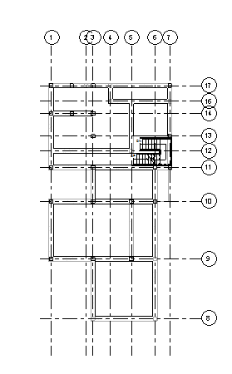

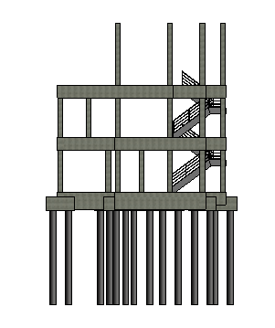

**WEEK 27**

**CONSTRUCTION ACTIVITY:** Stairs to the Second Floor

**DURATION:** 6 Days

**MATERIALS:** Concrete grade 30, timber formwork, reinforcement.

**EQUIPMENTS:** Bar bending machine, concrete vibrator, tools, scaffolding, steel trowel

**SKILLED WORKER:** Carpenters, General workers, Labours

**TECHNICAL INFORMATION:**

* The staircase is built to connect the ground floor to the second floor.

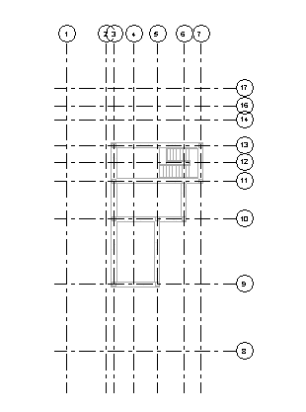

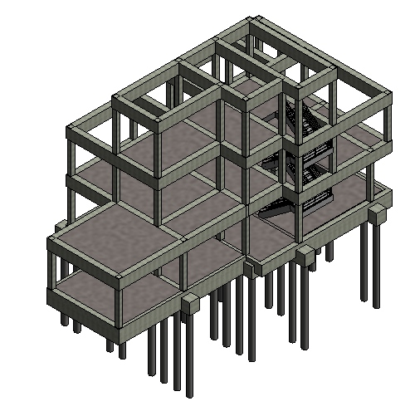

**WEEK 28**

**CONSTRUCTION ACTIVITY:** Roof Beam

**DURATION:** 6 Days

**MATERIALS:** Concrete grade 30, timber formwork, reinforcement.

**EQUIPMENTS:** Bar bending machine, concrete vibrator, tools, scaffolding, steel trowel

**SKILLED WORKER:** Carpenters, General workers, Labours

**TECHNICAL INFORMATION:**

* The beam construction is continued to the roof by connecting the structural column of the second floor.
* This beam acts as frame for the roof.

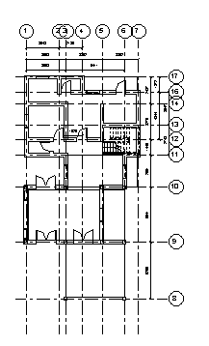

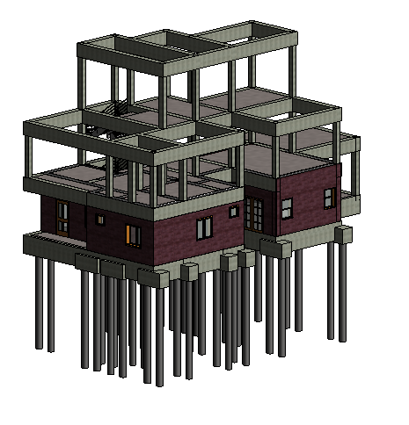

**WEEK 29**

**CONSTRUCTION ACTIVITY:** Ground Floor Bricks Walls 1

**DURATION:** 6 Days

**MATERIALS:** Clay bricks, mortar

**EQUIPMENTS:** Bucket, Steel trowel, Tools

**SKILLED WORKER:** General workers, Labours

**TECHNICAL INFORMATION:**

* The exterior brick wall is created using the bricks to give the form of the house.

**WEEK 30**

**CONSTRUCTION ACTIVITY:** Ground Floor Bricks Walls 2

**DURATION:** 6 Days

**MATERIALS:** Clay bricks, mortar

**EQUIPMENTS:** Bucket, Steel trowel, Tools

**SKILLED WORKER:** General workers, Labours

**TECHNICAL INFORMATION:**

* The exterior brick wall is created using the bricks to give the form of the house.

**WEEK 31**

**CONSTRUCTION ACTIVITY:** Ground Floor Bricks Walls 3

**DURATION:** 6 Days

**MATERIALS:** Clay bricks, mortar

**EQUIPMENTS:** Bucket, Steel trowel, Tools

**SKILLED WORKER:** General workers, Labours

**TECHNICAL INFORMATION:**

* The exterior brick wall is created using the bricks to give the form of the house.

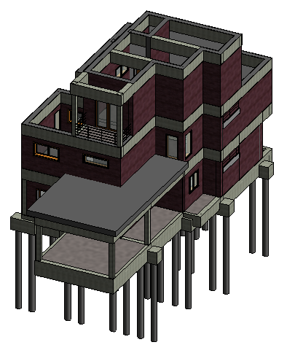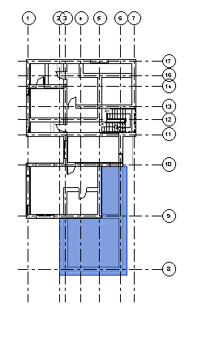

**WEEK 32**

**CONSTRUCTION ACTIVITY:** Construction of the Overhanging Roof

**DURATION:** 6 Days

**MATERIALS:** Concrete, Timber formwork

**EQUIPMENTS:** Bucket, Concrete vibrator, tools, scaffolding, steel trowel

**SKILLED WORKER:** General workers, Labours, Carpenter

**TECHNICAL INFORMATION:**

* Connected with the exterior walls of the ground floor to provide enough shades on the particular area.

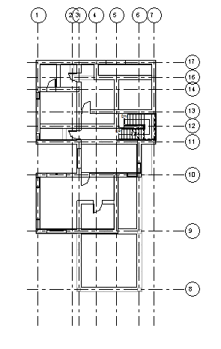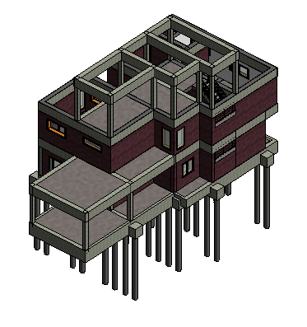

**WEEK 33**

**CONSTRUCTION ACTIVITY:** First Floor Bricks Walls 1

**DURATION:** 6 Days

**MATERIALS:** Clay bricks, mortar

**EQUIPMENTS:** Bucket, tools, scaffolding, steel trowel

**SKILLED WORKER:** General workers, Labours

**TECHNICAL INFORMATION:**

* The exterior brick wall is created using the bricks to give the form of the house.

**WEEK 34**

**CONSTRUCTION ACTIVITY:** First Floor Bricks Walls 2

**DURATION:** 6 Days

**MATERIALS:** Clay bricks, mortar

**EQUIPMENTS:** Bucket, tools, scaffolding, steel trowel

**SKILLED WORKER:** General workers, Labours

**TECHNICAL INFORMATION:**

* The exterior brick wall is created using the bricks to give the form of the house.

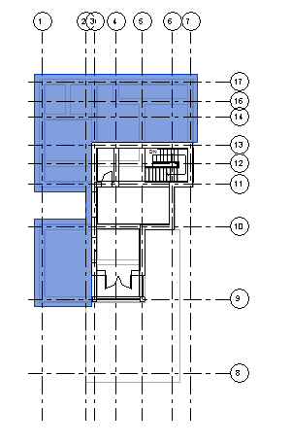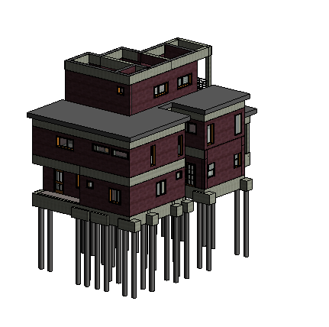

**WEEK 35**

**CONSTRUCTION ACTIVITY:** Construction of the Overhanging Roof

**DURATION:** 6 Days

**MATERIALS:** Concrete, Timber formwork

**EQUIPMENTS:** Bucket, Concrete vibrator, tools, scaffolding, steel trowel

**SKILLED WORKER:** General workers, Labours, Carpenter

**TECHNICAL INFORMATION:**

* Connected with the exterior walls of the first floor to provide enough shades on the particular area.

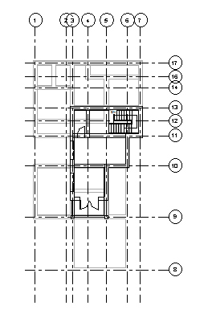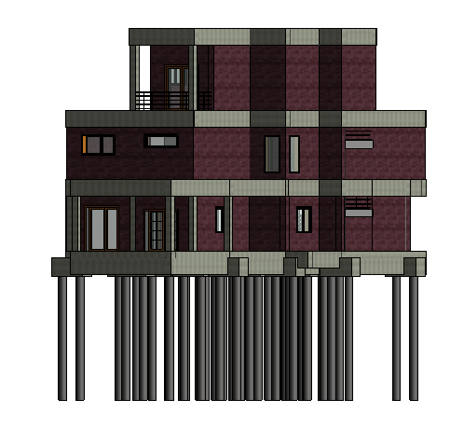

**WEEK 36**

**CONSTRUCTION ACTIVITY:** Second Floor Bricks Walls 1

**DURATION:** 6 Days

**MATERIALS:** Clay bricks, mortar

**EQUIPMENTS:** Bucket, tools, scaffolding, steel trowel

**SKILLED WORKER:** General workers, Labours

**TECHNICAL INFORMATION:**

* The exterior brick wall is created using the bricks to give the form of the house.

**WEEK 37**

**CONSTRUCTION ACTIVITY:** Second Floor Bricks Walls 2

**DURATION:** 6 Days

**MATERIALS:** Clay bricks, mortar

**EQUIPMENTS:** Bucket, tools, scaffolding, steel trowel

**SKILLED WORKER:** General workers, Labours

**TECHNICAL INFORMATION:**

* The exterior brick wall is created using the bricks to give the form of the house.

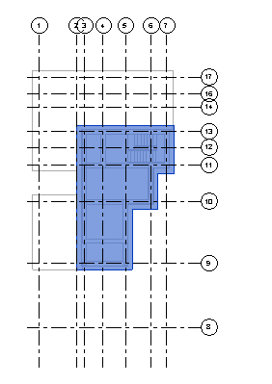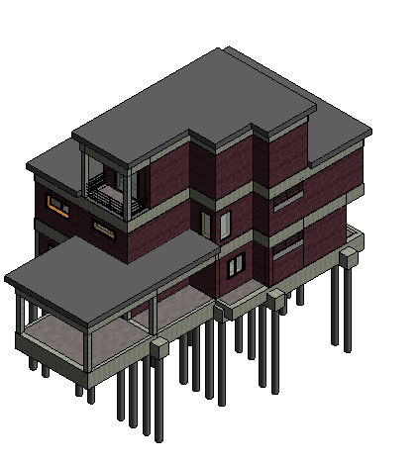

**WEEK 38**

**CONSTRUCTION ACTIVITY:** Roof Installation

**DURATION:** 6 Days

**MATERIALS:** Clay tiles, Structural steel frame

**EQUIPMENTS:** Tools, Scaffolding

**SKILLED WORKER:** General workers, Labours

**TECHNICAL INFORMATION:**

* Clay tiles roof installation

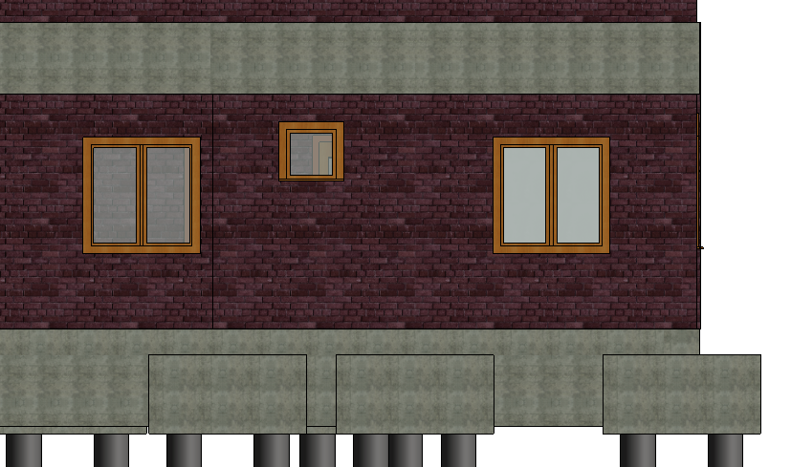

**WEEK 39**

**CONSTRUCTION ACTIVITY:** Door and Windows Frame Installation

**DURATION:** 6 Days

**MATERIALS:** timber and aluminium framing

**EQUIPMENTS:** Hammers, nails, L-rulers, tools

**SKILLED WORKER:** General workers, Labours, Carpenter

**TECHNICAL INFORMATION:**

* The frames for windows and doors is installed and acted as protection for the windows and doors.

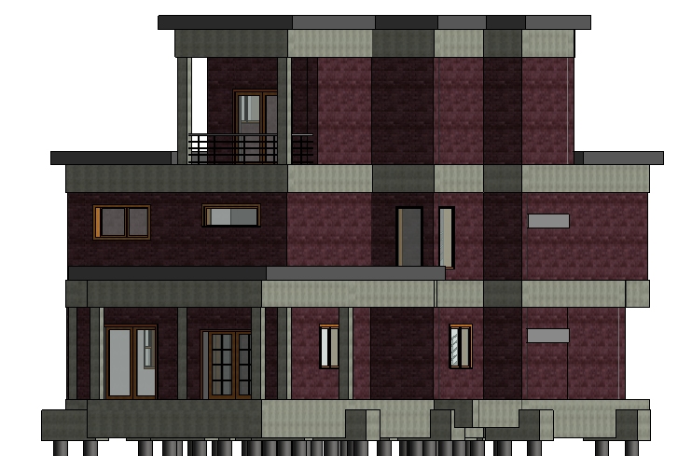

**WEEK 40**

**CONSTRUCTION ACTIVITY:** Doors and Windows Installation

**DURATION:** 6 Days

**MATERIALS:** Chosen Windows and Doors

**EQUIPMENTS:** Hammer, Nails, Screwdriver, Screws, Tools

**SKILLED WORKER:** General workers, Labours, Carpenter

**TECHNICAL INFORMATION:**

* Windows and doors is installed after the frames are done.

**WEEK 41**

**CONSTRUCTION ACTIVITY:** Plumbing and Electrical Installation 1

**DURATION:** 6 Days

**MATERIALS:** Pipes and wires. (Suitable for house plumbing and electrical wiring-standards)

**EQUIPMENTS:** saw, pliers, cutters, sealers, tools

**SKILLED WORKER:** Plumber, Electrical Engineer, General Workers, Carpenter, Labours

**TECHNICAL INFORMATION:**

* Power sources and water supply is installed to the house according to the plan provided.

**WEEK 42**

**CONSTRUCTION ACTIVITY:** Plumbing and Electrical Installation 2

**DURATION:** 6 Days

**MATERIALS:** Pipes and wires. (Suitable for house plumbing and electrical wiring-standards)

**EQUIPMENTS:** saw, pliers, cutters, sealers, tools

**SKILLED WORKER:** Plumber, Electrical Engineer, General Workers, Carpenter, Labours

**TECHNICAL INFORMATION:**

* Power sources and water supply is installed to the house according to the plan provided.

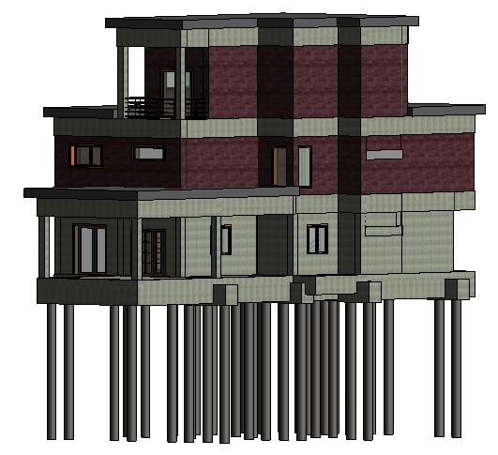

**WEEK 43**

**CONSTRUCTION ACTIVITY:** Wall and Ceiling Plastering 1

**DURATION:** 6 Days

**MATERIALS:** 15mm wall plaster, fiber glass gypsum for ceiling

**EQUIPMENTS:** Step ladders, Bucket, tools, scaffolding, steel trowel

**SKILLED WORKER:** General workers, Labours

**TECHNICAL INFORMATION:**

* The wall and ceiling is finished to provide the clean and beautiful view of the house.

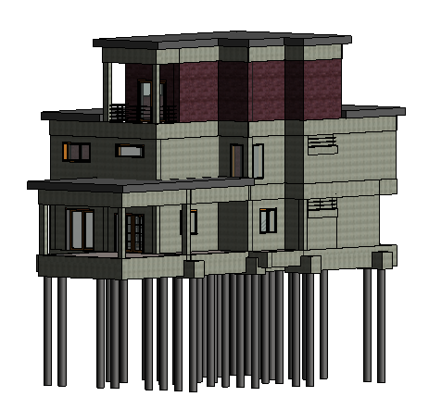

**WEEK 44**

**CONSTRUCTION ACTIVITY:** Wall and Ceiling Plastering 2

**DURATION:** 6 Days

**MATERIALS:** 15mm wall plaster, fiber glass gypsum for ceiling

**EQUIPMENTS:** Step ladders, Bucket, tools, scaffolding, steel trowel

**SKILLED WORKER:** General workers, Labours

**TECHNICAL INFORMATION:**

* The wall and ceiling is finished to provide the clean and beautiful view of the house.

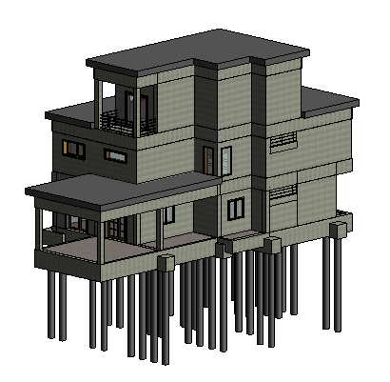

**WEEK 45**

**CONSTRUCTION ACTIVITY:** Wall and Ceiling Plastering 3

**DURATION:** 6 Days

**MATERIALS:** 15mm wall plaster, fiber glass gypsum for ceiling

**EQUIPMENTS:** Step ladders, Bucket, tools, scaffolding, steel trowel

**SKILLED WORKER:** General workers, Labours

**TECHNICAL INFORMATION:**

* The wall and ceiling is finished to provide the clean and beautiful view of the house.

**WEEK 46 – WEEK 47**

**CONSTRUCTION ACTIVITY:** Tiles Installation for Interior and Exterior

**DURATION:** 12 Days

**MATERIALS:** Marble tiles for living room and kitchen, solid timber flooring for bedroom, porcelain for wet kitchen, homogenous tiles for yard and terrace on ground floor and roof terrace, pebble wash for car porch and balcony, and mortar.

**EQUIPMENTS:** Tiles cutter, steel trowel, hammers and nails, tools

**SKILLED WORKER:** General Workers, Labours

**TECHNICAL INFORMATION:**

* Another finishing steps for the house, which is tiles installation. Various type of flooring is used to create a great look of the house inside.

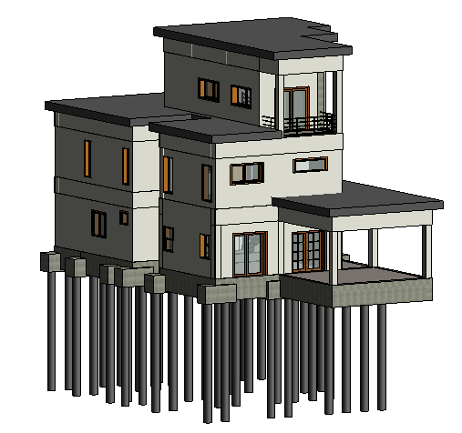

**WEEK 48 – WEEK 49**

**CONSTRUCTION ACTIVITY:** Painting and Finishing exterior and interior

**DURATION:** 12 Days

**MATERIALS:** Primer, interior and exterior coloured paint, wire mesh.

**EQUIPMENTS:** brush rollers, step ladders and extension ladders, bristle brush, wire brush, paint scrapers, masking tape.

**SKILLED WORKER:** General Workers, Painters, Labours

**TECHNICAL INFORMATION:**

* Another finishing steps for the house, which is painiting. Various type of colours were used to create a great look of the house inside and outside.

**WEEK 50 – WEEK 51**

**CONSTRUCTION ACTIVITY:** Fixed furniture such lights, tables, drawers, cabinets, cupboards installation

**DURATION:** 12 Days

**MATERIALS:** Medium and soft wood, strong glue, varnish, paint, water heater, light bulbs, fixed electrical appliances

**EQUIPMENTS:** Hammers and nails, Table saw, utility cutters, tools

**SKILLED WORKER:** Electrical appliances expert, interior designer, general worker.

**TECHNICAL INFORMATION:**

* The process to beautify the house by installing the fixed furniture, cabinets, cupboards, tables etc. The right furniture will create the beautiful house interior. Normally, the interior designer is in charge to make sure the house is beautifully decorated.

**WEEK 52**

**CONSTRUCTION ACTIVITY:** Final Inspection

**DURATION:** 6 Days

**MATERIALS:** -

**EQUIPMENTS:** -

**SKILLED WORKER:** Contractors, Engineers, Developers.

**TECHNICAL INFORMATION:**

* After the house is completely finished, it is time for the contractors, engineers or developers to give it a look whether it meets the requirement or not. In this phase, the house must be well inspected to make sure it is safe to live.

**WEEK 53**

**CONSTRUCTION ACTIVITY:** Cleaning Site

**DURATION:** 6 Days

**EQUIPMENTS:** cloths, water cleaning agent, mop, broom, vacuum

**SKILLED WORKER:** General Workers

**TECHNICAL INFORMATION:**

* The house is cleaned up to get ready to be released to the customer.