THE WILLITS HOUSE: MASSING

The Willits House is one of the greatest buildings designed by architect Frank Lloyd Wright. Designed in 1901, this building is the first building using prairie style. Based on his dictum, “Form follows function – that has been misunderstood. Form and function should be one, joined in a spiritual union”, is applied on this building. Research was done on this building and the chosen theme is massing.

The Willits House is mainly about the Prairie Style, which was pioneered by Frank Lloyd Wright himself. The prairie style itself affects the massing of the building. Most of the prairie style building was built from the basic shape which is cube or rectangular shape. Wright thought that the “space inside the building was more important than its enclosure” and, from this believed, he “open the box.” The box was described as the basic shape of the building itself which is rectangular or cube shape. Then, he added additional rectangular shapes for the other parts of the house. Besides that, it also has triangular roof shape. In addition, the Prairie style founded by Frank Lloyd Wright shared several features with American Foursquare style such as the square shape. However it does not has low-pitches roofs like the Willits House. Moreover, the shape and design for prairie style also influenced by Richardsonian Romanesque Style which has strong picturesque of massing.

As a conclusion, the Willits House’s massing reflects Frank Lloyd Wright’s design philosophy. The massing for the Willits House style then were applied for the other prairie style building such as The Darwin Martin House and Robie House. With the philosophy of Frank Lloyd Wright’s being focused more on function, the house really reflects the function of being a residential house.

**REFERENCES**

**Website:**

* Craven, J., (n.d.), 1893-1920: Prairie Style, a Revolutionary New House

Style by Frank Lloyd Wright. Retrieved from <http://architecture.about.com/od/periodsstyles/ig/House-Styles/The-Robie-House.htm>

### Frank Lloyd Wright - The Prairie Style: From Theory to Practice. (n.d.), Retrieved from

<http://www.westcotthouse.org/prairie_style.html>

* Richardsonian Romanesque. (n.d.), Retrieved from

<http://en.wikipedia.org/wiki/Richardsonian_Romanesque_architecture>

* Willits House. (n.d.), Retrieved from <http://www.waymarking.com/waymarks/WM2GQJ>

**REFERENCE MATERIALS**

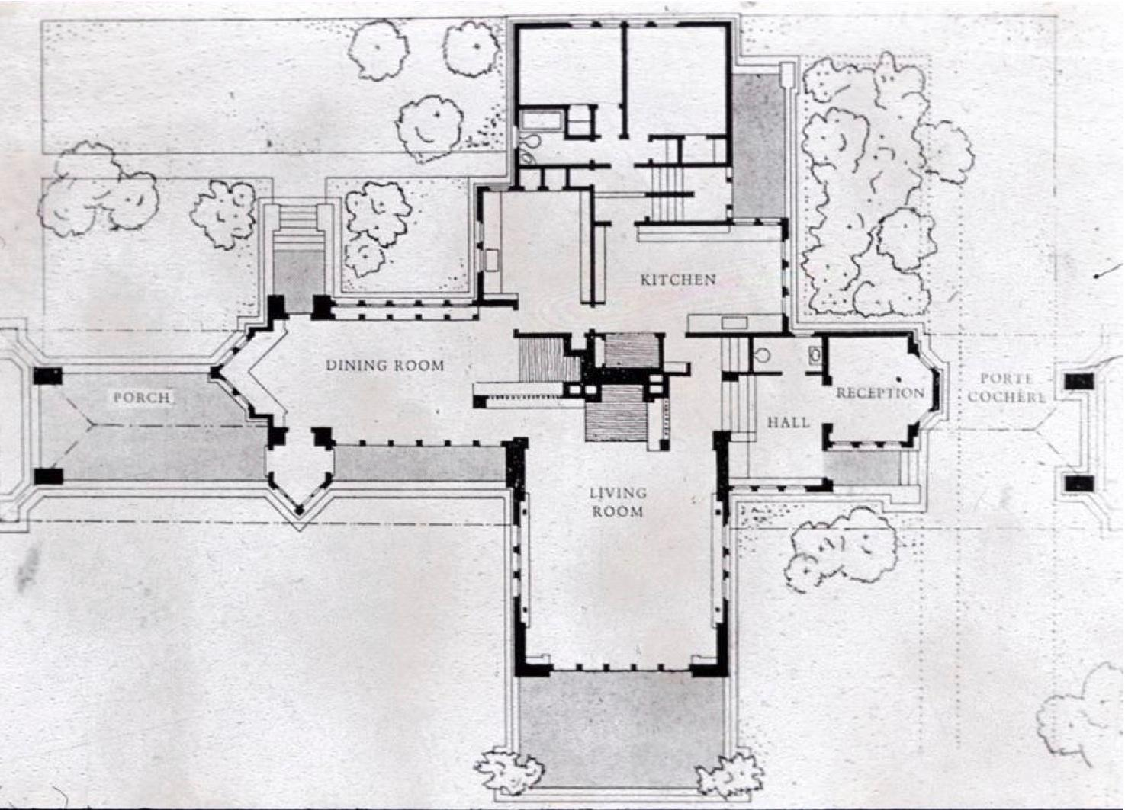

Figure 1: The Willits House Floor Plan and Massing

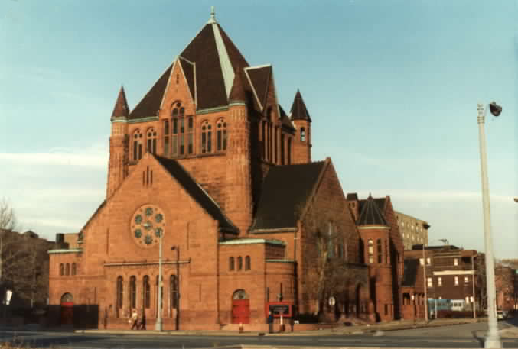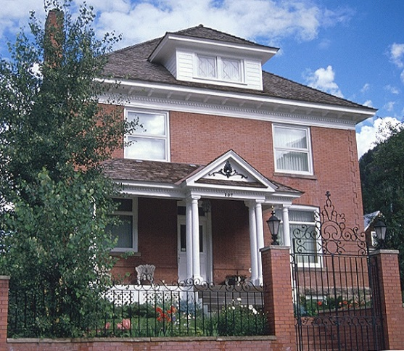

Figure 3: Richardsonian Romanesque Architecture

Figure 2: American Foursquare Style

MASSING OF THE WILLITS HOUSE

By

MOHD SHAHRUL IZZAT BIN ABDULLAH

(0317185)