NATURE AND US (GROUP ESSAY)

NATURE AS COMMUNITY

What is the backbone of a country or an institution? It is the community, it goes the same for families, residential, politics, and plus The Nature. When the word community is being said, most people would think about people generally, it is true, but if they are thinking of a global community, nature is part of them without a doubt. How would a large amount of population would survive without the nature giving us sources for food, space for shelter and sources for raw materials such as fuels and construction materials. There are many issues nowadays concerning the built environment, nature and the human communities. Developing built environments always have this problem of being opposed by many people because it destroys most of the essence this world has had since many years ago as it will eventually cause catastrophic environmental pollutions that corresponds to the nature having more problems that will have difficulties for the future generation. The community, as in human communities should fix this problem together, but we rather put blame on each other and cause more fights and war that has been and will be causing more environmental problems to come around. These all move in a circle of 360 degree angle, that when one problem happens, another comes and affect another that eventually will give effect to the first problem all over again. Once these things happen, it will never stop, as there is an old saying that says, “What goes around comes back around”.

The built environment is an issue that has to have a controlled usage and implications as it will take its effect on toll if being harvest limitlessly. It has a dramatic impact on the hydrological cycle as well. Increased physical development and impervious surfaces mean there are less natural features to absorb rainwater, leading to greater runoff and flooding. The loss of open space results in less water Infiltration into the ground and less evapotranspiration of water and moisture back into the air due to the loss of plants and trees. The quality of our water is diminished due to runoff, seepage, waste or toxins, and groundwater discharge all of which are the result of the built environment. The total cost on the environment must be accounted for when thinking sustainably. The embodied energy, the energy needed to produce or transport materials, is referred to as the real cost of building or producing something. Each phase of the process requires energy, but not all phases are considered when thinking about usage. When we think about sustainability we need to consider all aspects of production, and attempt to reduce energy consumption whenever we can. When this process occurs, there are land being ventured, wastes being thrown to the sea, developers will be rich and the earth will suffer from its physical state being damaged. Flora and fauna will decrease hence, causing an unbalanced food chain system globally.

The conservation of ecosystems and the species within them would help to maintain the natural balances disrupted by recent human activity. A report from the global conservation organization, WWF, has suggested that since 1970 the pressure we exert on the planet has almost doubled and the natural resources upon which we depend have declined by more than 33%. Unfortunately, despite the effort put into conservation by organizations and activists, their work can easily be undermined by those who have other interests. This occurs, for example, from habitat destruction, illegal poaching, to influencing or manipulating laws designed to protect species. The current form of globalization has also been criticized for ignoring sustainable development and environmental concerns. For many years, critics, NGOs, activists and affected peoples have been accusing large corporations for being major sources of environmental problems. In a research conducted by World Conservation Union (IUCN) from 2005-2013, there are declining number of large carnivores and animals like tigers, lions and rhinos. It is nearing the extinction of vultures in India, and plus the declination of population includes polar bears, penguins, amphibians, monkeys, apes and a number of other primates. They also found the low frequency of active sonar effect whales, dolphins and many sea creatures. Even though everything sounds it is getting worse as it goes, but there are many new species still being found throughout the whole, making conservation more important. If our community didn’t destroy as much as they did now back then, we would have discovered many other species.

Actually, the main problem for us is that we have lost our sense of awareness towards the nature. This happen when we are too busy with our daily routine that we do not know what happen to the mother nature. We live and work behind the concrete walls with controlled climate, our sight were blocked by the windows, our cars had cut off the landscape and the air conditioning is turned on, prevent us from the natural breeze blow. We repeat the same things every day until we forgot to appreciate on what the nature has provide to us. Lastly, the lack of sense of awareness will accidentally make us don’t really care about the nature. When there are some nature issues raised, we will know nothing about that.

In many occasions, the nature has suffered severely and it will drag us too into many problems. For example, the hill levelling activity will cause many trees to be cut down. If this thing happens, the amount of trees will decrease and we will face an even greater global warming. That is why nature is part of the community and they are related to each other. Everybody needs to have the sense of awareness towards the nature and we need to start to expose the next generation about the importance of nature.

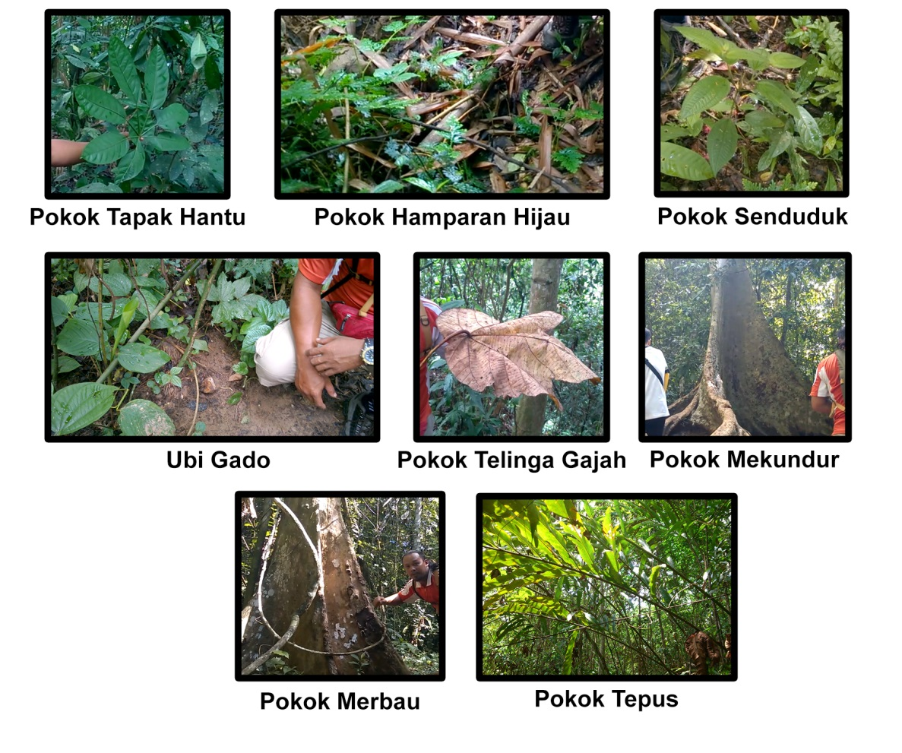

Every plants has their of advantages that benificial to animals and human

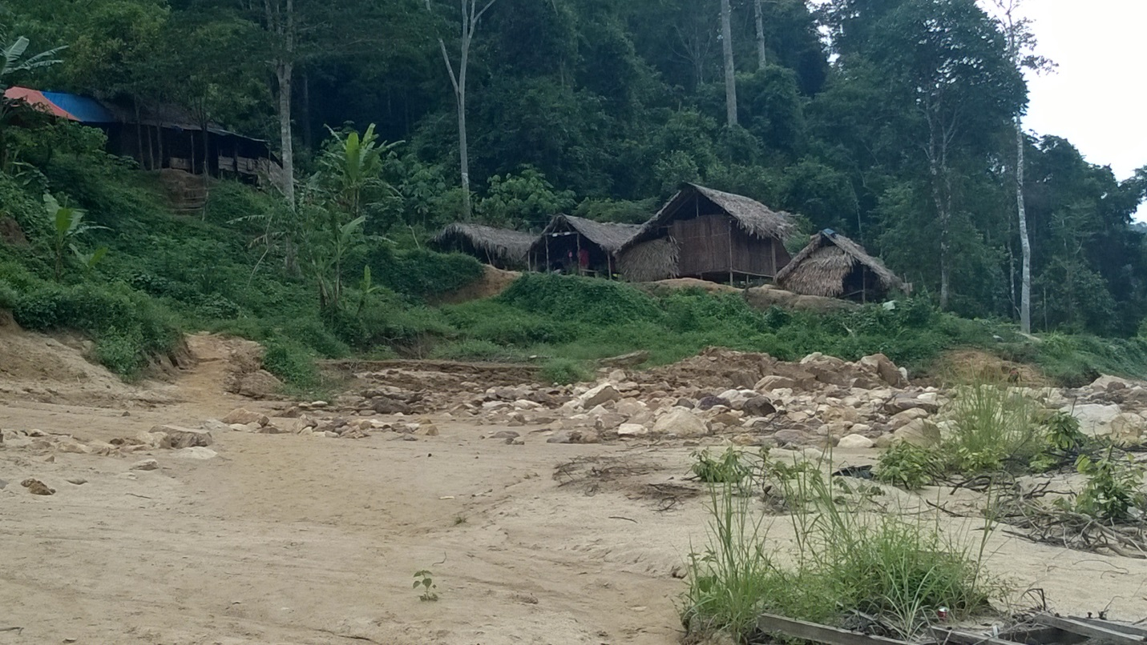Why we must consider the nature as a community? From our experience visiting Kuala Tahan National Park, there are a lot of flora and fauna that relate and give benefit to each other. For example, there are some plants that are useful for human as medicine and food. The indigenous people or known as *Orang Asli*, they make fully use the benefits of those plants. The plants react as primary producer in the food chain followed by human and animals as the consumers. From this basic food chain, a food web pattern will show how the nature forms a community. However, we have to make sure the balance of the ecosystem is well taken care of. That is why the awareness towards the nature must be considered. The natural resources from the nature also play an important role for *Orang Asli* as they are still depend on the sources there. Being in Kuala Tahan National Park, is the best answer on how the nature is part of community because we can see in details the relationship between humans who is *Orang asli*, and the flora and fauna. We cannot imagine how the Orang Asli would live their life culturally without the forest, animals, the plants.

Orang Asli's village which is located by the river near the forest

In a conclusion, no matter how advanced we are, we just cannot ignore the nature as part of our community. Kuala Tahan National Park is one of the best examples for nature reservation provided by the government. This kind of place has to be built not for buildings, but for natural habitats to be better and to be preserved to ensure the continuity of nature. By understanding the importance of the nature, it can help us to understand more about the relationship between the human and mother nature.

References:

Current Issues Related to the Sustainability of the Built Environment - eXtension. (n.d.). Current Issues Related to the Sustainability of the Built Environment - eXtension. Retrieved June 26, 2014, from http://www.extension.org/pages/61805/current-issues-related-to-the-sustainability-of-the-built-environment#.U6xXso2SzZc

Nature and Animal Conservation. (n.d.). - Global Issues. Retrieved June 26, 2014, from http://www.globalissues.org/article/177/nature-and-animal-conservation