

**Culture and History 2 [ ARC 60203]**

**PROJECT 2: Web Book (Group & Individual)**

**Hospital Kuala Lumpur**

**MOHD SHARHRUL IZZAT B.ABDULLAH 0317185**

**NAREAN PUNITHARAJAH 0315746**

**MUHAMMAD FARIDZUL FIKRI B. JEFFRY 0311836**

**MUHAMMAD MUZHAMMIL B.AZHAM 0311446**

**PRESHANT RASU 0312813**

**LYDIA AMALINA**

LECTURER: Miss Shahrianne Mohd Shah

SUBMISSION DATE: 23 June 2014

**TABLE OF CONTENTS**

Introduction…………………………………………………………………………………………………. 3

Architectural Style Analysis…………………………………………………………………………… 4

Building Construction and Material Analysis…………………………………………………. 8

Architectural Elements…………………………………………………………………………………. 11

Conclusion……………………………………………………………………………………………………. 14

References……………………………………………………………………………………………………. 15

**INTRODUCTION**

The search of national identity for every country is compulsory especially when it is used to represent their architecture style. However in Malaysia, the search of identity is a very difficult attempt due to the multi-cultural nation. In the west, architects were concerned with the various philosophical in solving the identity problem. It started when Frank Lloyd Wright was concerned about the definition of a truly American and democratic architecture. It was followed by Le Corbusier’s concerned of mass-produced global architecture and internationalism. In the mid-19th century, Augustus Pugin was concerned with the idea of a true Christian architecture which he ultimately found to be embodied in the Gothic vocabulary whereas Louis Henry Sullivan philosophized his way through the idea of a noble classical architecture. For the rural areas, there was remnant of native architecture whose only philosophy is to seek shelter in the best way with a spatial layout exactly in consonance with the people’s way of life. These traditions were brought into Malaysia by local architects who studied in the West. In the 1960’s the modernistic expressionism was used in Malaysia. The modernist design was represented in the building as a climate sieve machine without directly translated from the historical reference. The expressionism on the other hand was shown by the structures that represent the abstract metaphors through certain bent in modernist architect. In Malaysia, the Parliament Building and the National Mosque are one of the best examples for this approach.

By:Izzat

**Architecture style analysis**

**INSPIRED BY FUNCTION**

Modern architecture breaks away from cookie-cutter design and traditional aesthetics.  It strives to create building designs that go beyond “standard” ideas and instead pursue projects inspired by layout, location, and function.  Frank Lloyd Wright’s mentor, Louis Sullivan famously stated that, “Form follows function”.  This idea is expressed by Modernisms’ tendency to have land or the function of a project dictate much of the design ideas.  For example, Wright was famous for building with the land - his residential homes almost always relied on the lot to determine how the building was to be laid out.  Wright believed that a building should be “one with the land” and not simply plopped down on top of it. Modernist architecture takes inspiration from the project itself - if the project is meant to showcase something, house something particular, or be occupied by a particular person, Modern architecture’s aim is to design for each unique situation and to be inspired by its purpose.

**SIMPLICITY IN FORM AND DESIGN**

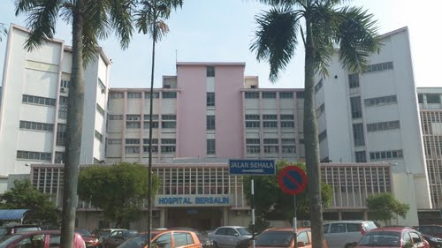

This building design really shows the Modernist architecture that is typically free of clutter and unnecessary elements. The goals of the project are clarified at the start, and only the features that are required are included in the design.  In other cases for residential homes are often stripped down to showcase the architectural design of the home - the focus will be on the space itself, rather than on any decor or details not relevant to the overall design. Homeowners following a Modern aesthetic believe strongly in the idea of “Less is more”!  Modern tastes enjoy simplicity and clarity.  Homes will be clean, functional, and simple.  There are varying degrees of Modernism - some will opt for the strict design sense of true Minimalism, while others prefer to incorporate the minimalist aesthetics of Modernism in conjunction with their own personal style. For this building adopted the style even though in most cases, the Modernism style are majorly used for houses. Having a good design elements in the way of colors, textures, and interesting furnishings will help create a more unique Modern style.

**NOTHING TO HIDE**

Rather than concealing the nature of the building, Modern style wants the viewer to see the inner-workings and the true nature of the project.  Materials are shown in the natural form and are showcased.  Nothing is hidden or altered to look like something else.  Structural elements are revealed to show the structure and supports.  Exposed beams, open floor plans, and structural elements are exposed to the viewer.  The idea of a sense of “Truth” is present in the building, where all materials and architectural elements are bare and revealed honestly.

**LOVE OF ALL THINGS LINEAR**

In many Modern designs, I found that strong linear elements and bold horizontal and vertical features.  Beams, posts, cutouts, windows, staircases, roof lines, and other structural elements all assist the architect in creating a linear-inspired space.  This focus is much more prominent in Modern design and is less important in other, more traditional, building styles. From this building, we can almost see, it was built to be in a regular massing shape as a large cube as seem. Lines of Modern architecture tend to be straight and angled rather than curved; however organic lines can sneak their way into Modern home or any other smaller building designs due to the risks and difficulties that can occur during the construction.

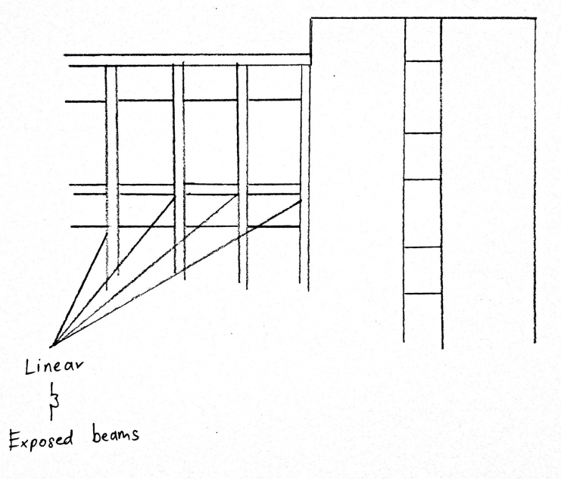

**BOLD ROOF LINES**

Instead of opting for the traditional triangular-based or craftsman style roof lines, Modern architecture dares to push the envelope on roof design. Residential homes might have multiple roof lines at different levels, showing off the complexity of the overall design and the uncommon silhouette of the structure. Varying lines and elongated vaulted ceilings, as well as interesting overhangs or unusual linear elements are mixed to create a more unique statement. This focus on the exterior design in one of the highlighting feature of Modern design.

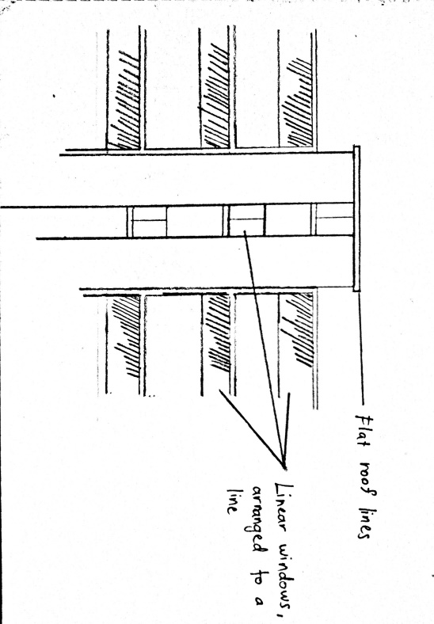

**WINDOWS AS DESIGN**

The number one usage of windows extensively to bring in light. They may also include “clerestory” windows that are set high in the walls of a home to let in light while preserving privacy.

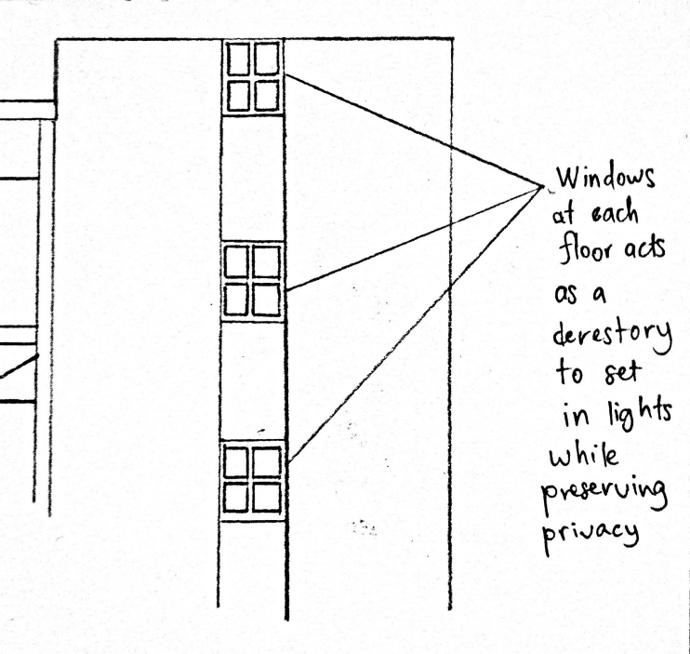

**POST-AND-BEAM ARCHITECTURE**

Instead of interior walls functioning as support walls, they serve more as room dividers or for appearance.  In many homes, “pony walls” extend from the floor to just below the ceiling, separating rooms while allowing them to share light. This can be seen through the long walls of this particular building, for the building’s manager, nurse’s rooms and the wards. As can be seen in the picture, the circulation for the employees are basically through a linear and straight line going back and forth to fulfill their work capacity and attending patients.

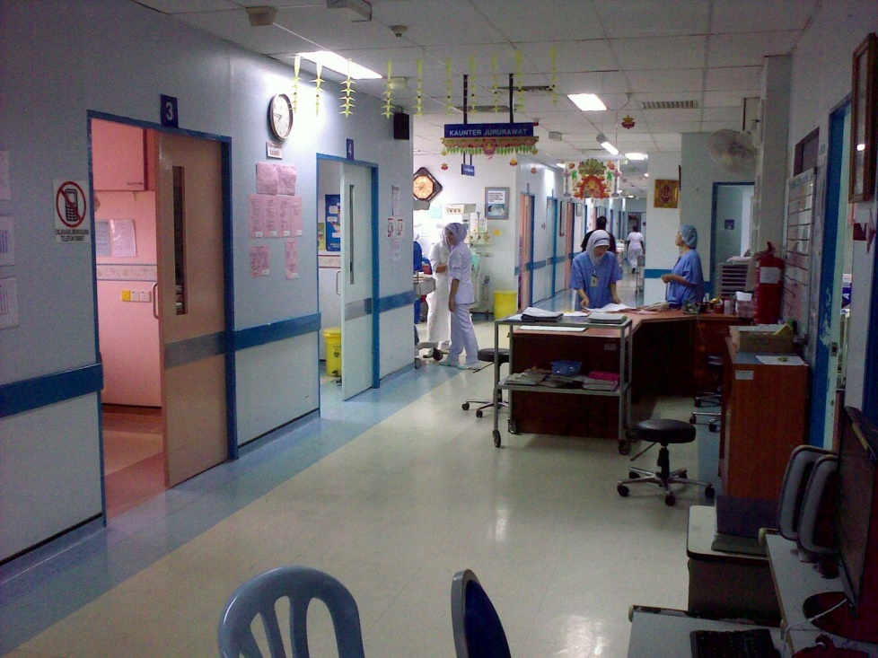

By: Muzhammil

The Le Corbusier’s brutalism architecture is shown in his Monastery La Tourette and Chandigarh. It is inspired the Malaysian counterparts of Kuala Lumpur General Hospital or known as Hospital Kuala Lumpur (HKL). There are many similarities in term of design and structures between the HKL and Le Corbusier’s brutalism architecture building. HKL was built during the Machine Regionalism approach. During that time, the architecture style in Malaysia was purely come from western influence. The main influences on HKL is the use of deep overhangs, “egg crate” recessed windows, louvered shade and openings with exposed concrete construction. There are many similarities in term of design and structures between the HKL and Le Corbusier’s brutalism architecture building.

By: Izzat

**Building Construction & Materials analysis**

As per out site visit, we were asked to recode and explain the building materials and construction methods used at the Hospital Kuala Lumpur. The first building material we observed is clay brick were used thought the building. These bricks are used in a masonry construction style (see figure A).

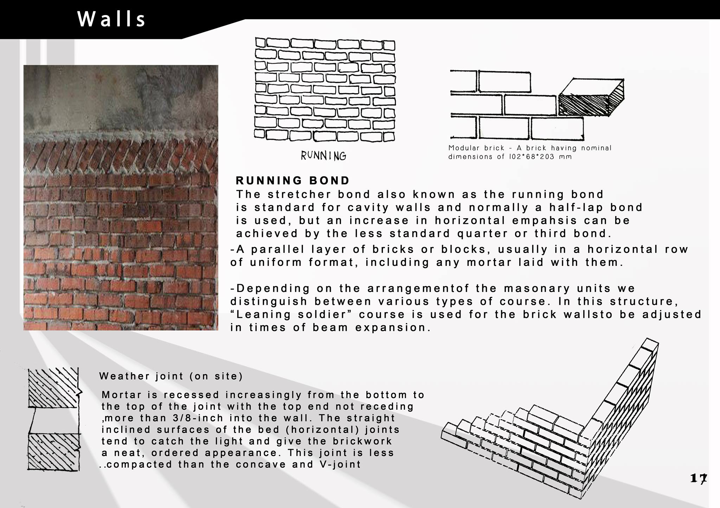

Figure A: Bricks arranged in masonry construct.

The bricks were typically stacked together and laid as brickwork using cement to hold the bricks together. Bricks have a porous structure, which help it to regulate heat making it a good heat insulator which keep the hospital cooler and gives a comfortable environment to be in.

Besides that is cement plaster and concrete. Cement plaster is a mixture of suitable plaster, sand, Portland cement and water which is normally applied to masonry interior and exteriors to achieve a smooth surface interior surface sometimes receive a final layer of gypsum plaster. Plaster was also be used to create detailing inside of the wads.

The concrete used is made from cement, water and aggregate. Concrete has high compressive strength as the aggregate efficiently carries the compression load .During the day heat is absorbed from the interior of the building and stored in the cooler mass of the concrete, hence requiring less energy to cool the hospital.

For the external façade, sun shading was observed.   The use of sun shading devices is to control the amount of light that penetrates into the building this ultimately give the thermal comfort inside the hospital to be in a comfortable range. The façade of the building has a variety of horizontal and vertical sun shading devices. The reason for this is because the building gets sunlight at different times of the day, at different angles. The Concrete sun shading shades the interior from high direct sunlight, also reducing the amount of heat in reaching the interior of the hospital.(see figure B)

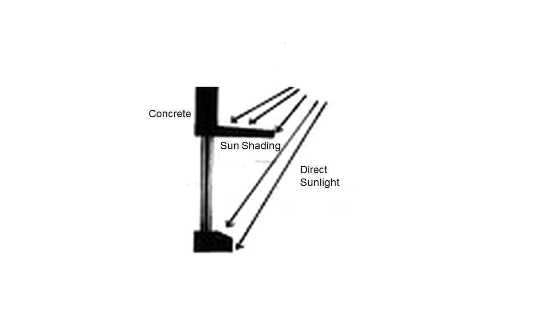

Figure B Shows sun shading.

By: Preshant

Aluminum windows (See figure C ) are cheaper and are the standard with most mainstream buildings. This makes it easier, quicker and cheaper to get parts and much needed glass repairs. Aluminum windows are more durable than wood and will not rust hence it last longer. Therefore this a good and reliable material in order to save cost in the long run.

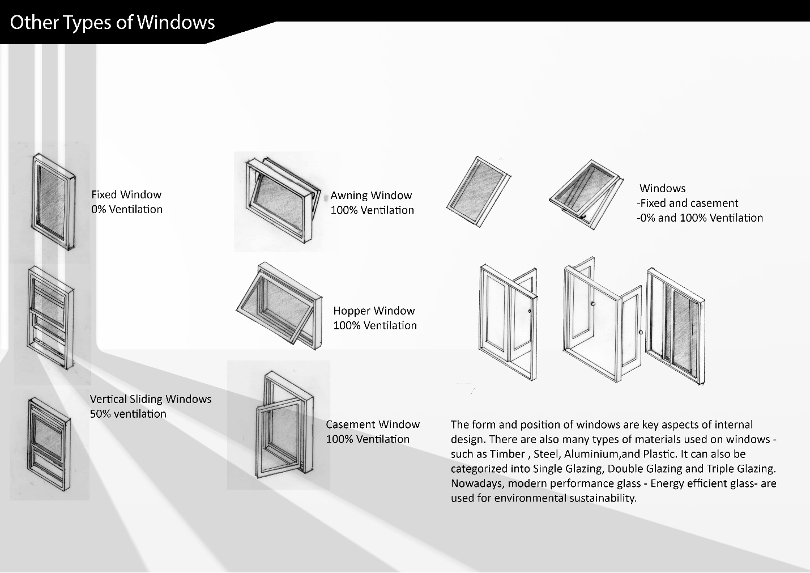

Figure C: Shows the types of windows observed.

For the foundation, the type of foundation is pile foundation. Pile foundation is a special type of foundation that enables a structure to be supported by a layer of soil found at any depth below the ground surface. (see figure D).

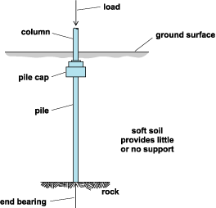

Figure D: Example of pile foundation.

The reason why pile foundation was used was because the soil is week therefore pilling is needed to strengthen the support in the ground and prevent the building from sinking in.

The type of roof used was flat roof. It is the most economical roof to build. The reason why flat roof was used was because it is strong enough to hold the water tanks the hospital uses has a thick mass which makes it able to resist the passage of moisture inside the building and for insulation purposes as it is able to reduce heat loss prevent excessive solar heat gain in hot weather.

The comparative study with the hospital Kuala Lumpur is with Villa Stein in Grechens. The difference in design is the sun shading effect. In the hospital Kuala Lumpur, there are large overpowering concrete blocks which make up the sun shading (See figure E). This is because, Malaysia has a tropical climate and average temperatures range from 24 to 35 Celsius. The sun shading blocks of excessive sun light from entering hence reducing cost needed to cool the hospital .On the other hand, Villa Stein(see figure F) is in Germany which has a milder climate with temperatures ranging from -5 to 12 Celsius (excluding summer) hence there are many open windows on the building to allow light and heat to enter, to save cost on heating.

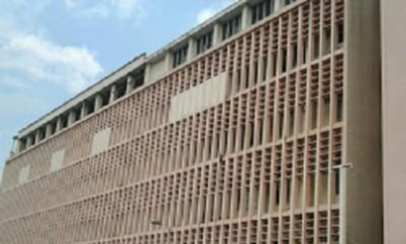

Figure E: Sun shading at Hospital Kuala Lumpur

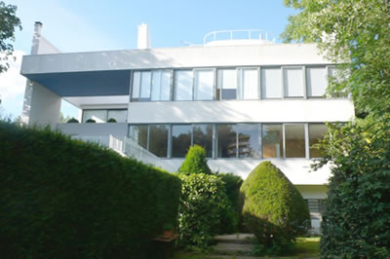

Figure F:Villa Stein

By : Narean

**Architectural elements**

General Hospital Kuala Lumpur was officially launched on 18th January 1963 and it was completed in late 1962. The building costly over RM 5 million. It has become one of the largest hospital under the Ministry of Health of Malaysia and considered one of the biggest in Asia. The largest department within this hospital was the Department of Obstetrics and Gynecology. It was located within the Maternity Block in the General Hospital Kuala Lumpur. Hospital Kuala Lumpur were started as district hospital comprising three main wards during 1970 to the local people, there are Tai Wah Ward, the Choudhry Ward and the Malay Ward. Afterwards, there is few constructions happened within year 1920 and 1962. Few phases for upgrading between the year 1962 and 1975 and it was completed at the cost of RM 77 million. Purposes of this hospital were not only to cater people, it also provides facilities to the trainees, nurses, and even housemen. Therefore, there are well equipped lecture theatre, a laboratory and a museum, a conference room and hospital accommodations. The largest department within General Hospital Kuala Lumpur were the Department of Obstetrics and Gynecology. Since 1963 to 2002, total babies were delivered were 759,335 deliveries have been conducted, this history makes this hospital one of the largest and busiest maternity hospital in the world.

Architectural elements within the Department of Obstetrics and Gynecology could been seen in few points of elements that were translated from modernism and Brutalist movement in the 60s which is happened in Malaysia. The Architect, Mr. K C Duncan were influenced by Le Corbusier’s work as Le Corbusier one of the famous modernist Architect in the 1920s. Few similarities were point out in the Department of Obstetrics and Gynecology and Le Corbusier’s High Court Chandigarh, India. A box-like designated were produce in the final product but the Department of Obstetrics have the influenced of Brutalist movement. Louvers windows which are in fixed construction made out from raw concrete as the main materials in the buildings. During the construction of the maternity hospital of Kuala Lumpur, prefabricated construction was unpopular in Kuala Lumpur. Producing the louvers windows in the department were provides little savings. Moreover, within the installation of the louvers windows creates a good ventilation as the hospital were protected by a series of square concrete louvers. It almost like a sarcophagus, which bring a greats aesthetics issue and also a greater degree of fire safety compared to grilles. The louvers were painted in lilac or orang in color as the bare concrete sections were damped in beige colors. This is whereas, the Le Corbusier’s influenced can be trash out from the modernist architecture. Overly the windows in the Department of Obstetrics and Gynecology were horizontal windows and form a rectangular openings in the façade which allows the light and air enter copiously. Through the eyes of horizontal window, reinforced concrete providing the possibility of maximum illumination. From support to support, windows were extends and becomes a horizontal windows. A rectilinear form were seen in the façade from the construction of the horizontal windows of the building and louvers windows. Through the center which stated the location of the stairs were totally wrapped by the form of rectilinear form and likely creates a biomimetic skins to the part of the building itself. By projecting the floor beyond the supporting pillars, the whole façade is extended from the supporting construction. It is a free designing of the ground floor which support systems carries throughout the plan from the intermediate ceilings and rises up to the roof. Each floor had the same floor plan and this is makes it easy to offset the high cost of reinforced concrete construction. The roof where part of the most important as it’s creates the humidity and protection from sun and rain. The flat roof made out of reinforced concrete helps protection against the changing of temperature. The part of flat roof could be compare the similarities that were designated by Le Corbusier’s High Court Chandigarh, India. By using the same materials and concept, the minimalist of modernism were produced. Overall, the building of the Department of Obstetrics and Gynecology are the reminiscent of the Le Corbusier’s High Court.

**Conclusion**

As a conclusion, Hospital Kuala Lumpur has modernism style architecture. Basically this building reflects Modernism architecture in a different manner in such way that the influence basically are all from western Modernism buildings rather than having a local influence because back in the era when it was built, there were not a lot of sophisticated buildings were being constructed locally for the architect to refer on. Architects will always survey or analyse the looks, design concept and characteristics that a building may has and comparing it to another building that has the same theme so the major influences can be seen. For this particular building, it was inspired by function that is design for each unique situation and to be inspired by its purpose. Plus, it has the simplicity in form and design that thrives to show the Modernist architecture that is typically free of clutter and unnecessary elements. The goals of the project are clarified at the start, and only the features that are required are included in the design. Basically this building is ‘honest’ in their designs and it doesn’t hide any true nature of the project. Materials are shown in the natural form and are showcased. Nothing is hidden or altered to look like something else. Structural elements are revealed to show the structure and supports. In addition to this point, everything is linear and beams, posts, cut outs, windows, staircases, rooflines, and other structural elements all assist the architect in creating a linear-inspired space. It uses the windows such as only for indirect lightings to occur as it uses interior lamps to shine the interior making the windows can be considered as a clerestory especially at the main staircases. They used up the post and beam architecture concept to make the interior walls functioning as support walls as they serve more as room dividers or for appearance.There are many similarities with Hospital Kuala Lumpur and Le Corbusier’s brutalism architecture. One of the main influences is the usage of the deep overhangs, recessed windows, louvered shade and openings with exposed concrete construction. In terms of the building construction and choice of materials, most of the materials chosen share similar traits such as being cheap, able to regulate heat to achieve thermal comfort as well as able to last long and require little maintenance .A comparative study shows that due to the different climates in Malaysia and Germany are different and as such sun shading varies. In Malaysia, the sun shading is used to reduce the amount of heat entering the building whereas in Germany, there are more windows to allow more light and heat to enter hence, heat up the building.

**Reference List**

1. Duggal, S. (2003). BUiding Materials. New Delhi: New Age International.
2. Construction and Building Materials. (n.d.). - ScienceDirect.com. Retrieved June 22, 2014, from <http://www.sciencedirect.com/science/journal/09500618>
3. Eberron Unlimited. (n.d.). List Of Materials Used For Construction -. Retrieved June 20, 2014, from <http://eberronunlimited.wikidot.com/list-of-materials-used-for-construction>
4. Ching, F., & Adams, C. (2001). Building construction illustrated (3rd ed.). New York: Wiley.
5. (n.d.)- [Distinctbuild.ca](http://distinctbuild.ca) .Retrieved June 22,2014<http://distinctbuild.ca/modern_architecture_defining_characteristics.php>