Kuala Tahan National Park which is located in Pahang is one of the most balanced ecosystems in Malaysia. Although it is built for tourism purpose, the ecosystem is still maintained as something valuable for the country and also for the next generation to appreciate what their country has. In Kuala Tahan National Park, there are a lot of activities for tourists such as Jungle Trekking, Night Jungle Walk, Boat Riding and Visiting Orang Asli Village. But the most important thing is, the variety of activities here never leave the natures harmed.

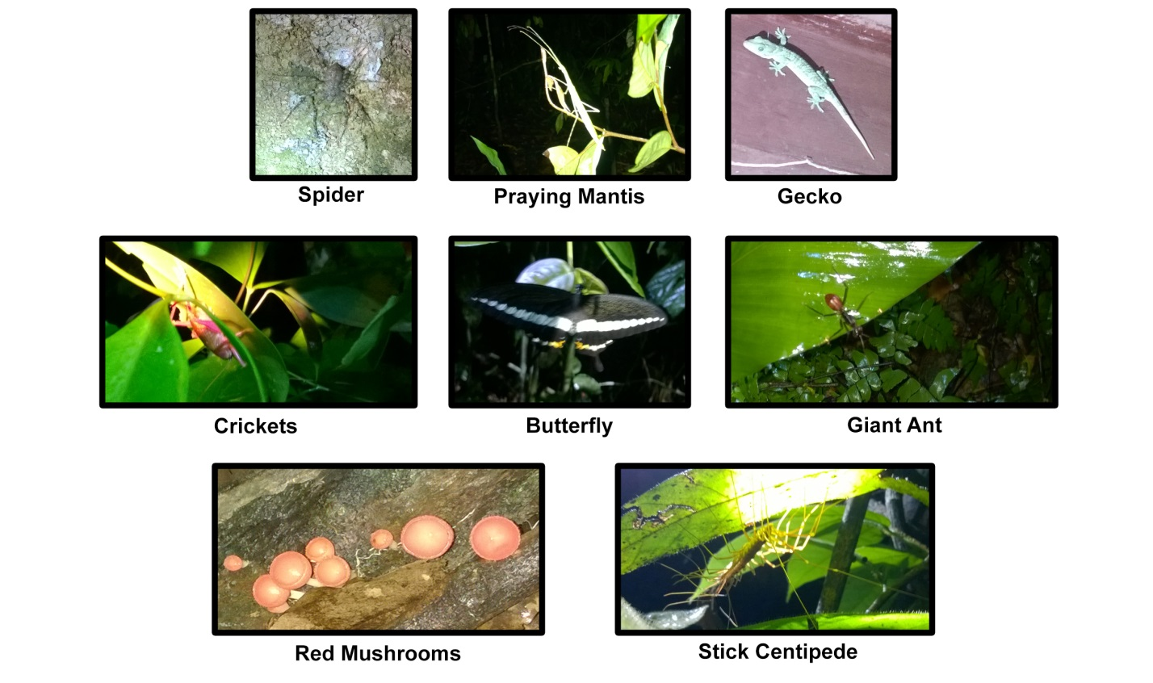During my time in National Park, I joined the group for the first activity which is Night Jungle Walk. A night walk is the best activity to do at Taman Negara. This activity was conducted inside the forest at night. We were guided by Mr. Awie, who works as a tourist guide there. We discovered the side of the jungle which comes alive at night. I found many nocturnal animals and plants during the walk. Nocturnal animals are the animals that active during the night and sleep during the day. Most of these animals have special adaptation to help them survive in the dark. For examples, there are some animals like owls and cats have special eyes which can see well in the dark. Some animals like bats survive at night by using echolocation which uses a high-pitched sound that bounces off objects. The sound is then received back by the bats to determine the object’s distance, shape, texture and direction. Other nocturnal animals also have good hearing capabilities that can help them survive from predators. While nocturnal plants are the plants that active at night to attract nocturnal pollinators such as bats and moths. We walked inside the forest and luckily there is wooden pathway that helps us to walk inside. This wooden pathway is useful especially for the tourists that walked into the forest for the first time. It made us feel comfortable because we did not have to use socks to avoid the leeches. Furthermore, the material used for the pathway is nature-based material which is wood. It is well-adapted with the forest compared using other material like concrete. We also used a canopy that was designed for the tourists to observe the nocturnal animals. But we were unlucky because we did not spot any animals from the canopy. We supposed to spot tigers, deers, and other animals.

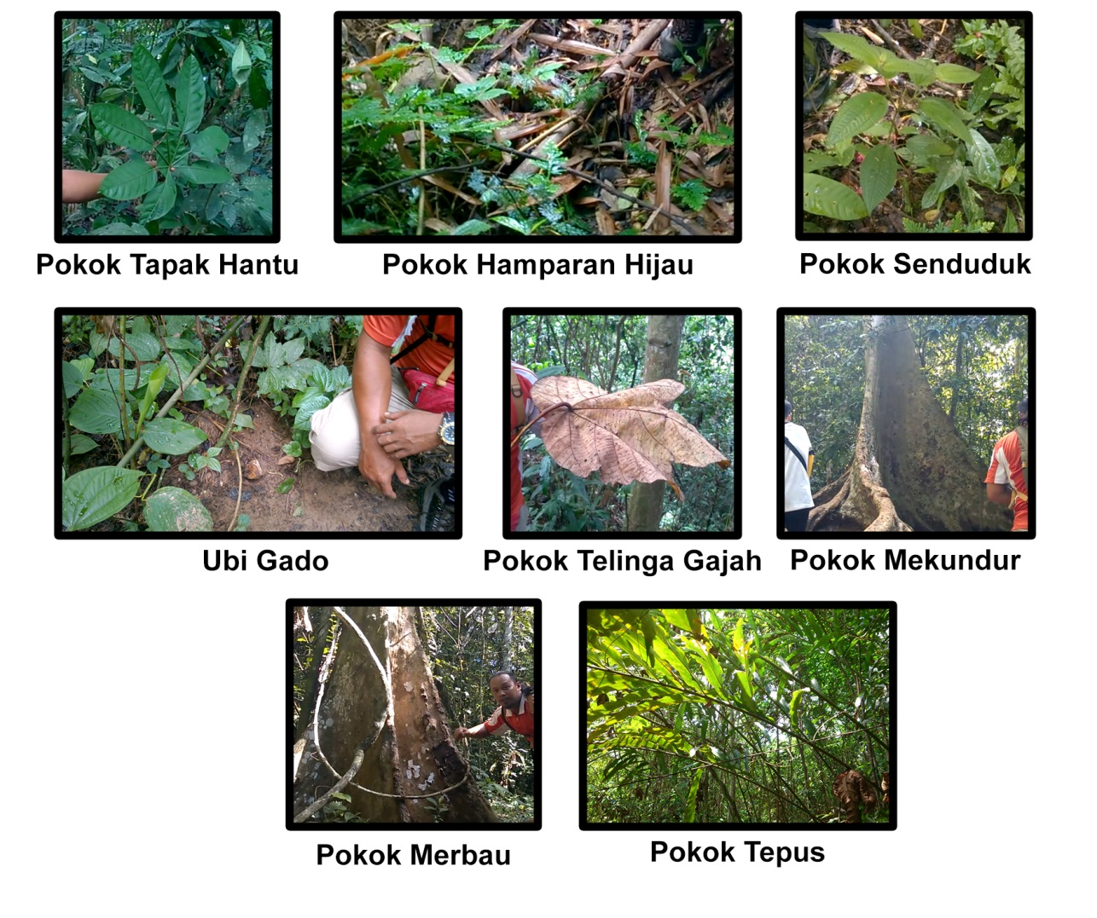On the second day, we had our next activity which was jungle trekking. This activity was quite tiring because we had to walk about 2 hours inside the jungle. The main purpose of this activity was to discover the biodiversity of the jungle. From this activity, we found many types of plants, insects and some animals. The plant that we never see before was *Pokok Tapak Hantu* or its scientific name is *Travesia burckii Boerl*. Based on what our tourist guide said, this plant has a prickly shrub to tree let up to 10 m tall and one of the ginseng family. Its habitat is a lowland forest and widely grown in Peninsular Malaysia. It also used by natives as aphrodisiac. Aphrodisiac is a substance that can increase human’s sexual desire. There was also a plant named *Peacock Fern* or in Malay, it is called *Hamparan Hijau.* The unique thing about this plant is it can change the colour from green to blue when it received enough sunlight. It also used as a medicine for asthma. There is a poisonous plant named *Ubi Gado* which only eaten by indigenous people or *Orang Asli*. This plant needs to be put into a river as the poison will be removed with the water’s flow. Animals like wild boar and hedgehog did not eat this plant because of the poison. We also found a tree named *Telinga Gajah* or *Elephant’s Ear* because the size of the leaf itself. Although the size of leaf is bigger, the tree is categorized as a soft tree. Usually the hard trees are located on the canopy side of the forest, which is at the surface of the forest. The hard trees are taller than soft trees and they have smaller leaves. The soft trees have bigger leaves which allow them to receive more sunlight easier. There is also a tree named *Pokok Tempus* which is widely used by indigenous people as an insect repellant. *Pokok Senduduk* or known as *Melastoma* is used as a medicine to cure small wounds. *Pokok Mekundur* is used as a natural tent. It also can protect people from wild animals*. Pokok Merbau* is used by indigenous people to communicate among them. The echo produced from this plant can reach up to 4 kilometer radius. After an hour of journey inside the forest, we arrived at *Bukit Terasek* for our next activity which is canopy walk. This is one of the longest Malaysia’s suspension bridge in the world which stretches about 530 m. The height is about 25 m to 40 m. Although this is my first time walk on the suspension bridge, I felt satisfied as I saw the floras and faunas at the summit of the forest.

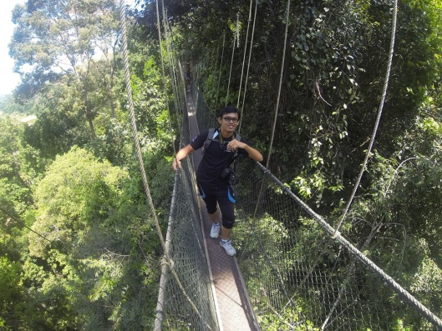

In the evening, we moved to our next activity which was rapid shooting. We went on a high speed boat across the *Sungai Tembeling*. We rode the boat according to the group before accompanied by our tourist guide. It was very exciting to ride the boat while watching the beautiful scenery from the river. After 15 minutes, we arrived at *Orang Asli* or indigenous people’s settlement. It is located by the river of *Sungai Tembeling*. The *Orang Asli* that we visited is from Batek clan,which was come from Papua New Guinea about 300,000 years ago. Their leader is known as *Tok Batin*. The Batek people are one of the Negrito tribes and have their own language and tradition. They are still living nomads compared to some clans that are now settled permanently near the national park. The economy resource of the Batek is based on hunting, collecting and trading. Sometimes, the tourists donated them some money. The Batek is also selling their crafts like blowpipes or *sumpit* and baskets to the tourists. They gained their food by hunting the animals inside the forest. Usually, they just hunt for the animals that stay on trees such as monkeys, birds and squirrel because they believed that these animals is good to be eaten because animals only eat fruits. They hunt the animals using a blowpipe or known as *sumpit* made from special bamboos from the foothills. The unique thing about them is when they want to get married, a guy must know how to make a blowpipe, fire, and hunt, while a girl need to know how to build a house. If they like each other, they will stay together as a symbol of marriage. The Batek people are still believed in animism. Based on their belief, when one of them is dead, they will bury the corpse on a tree. After that, they will move to other place to find their new home.

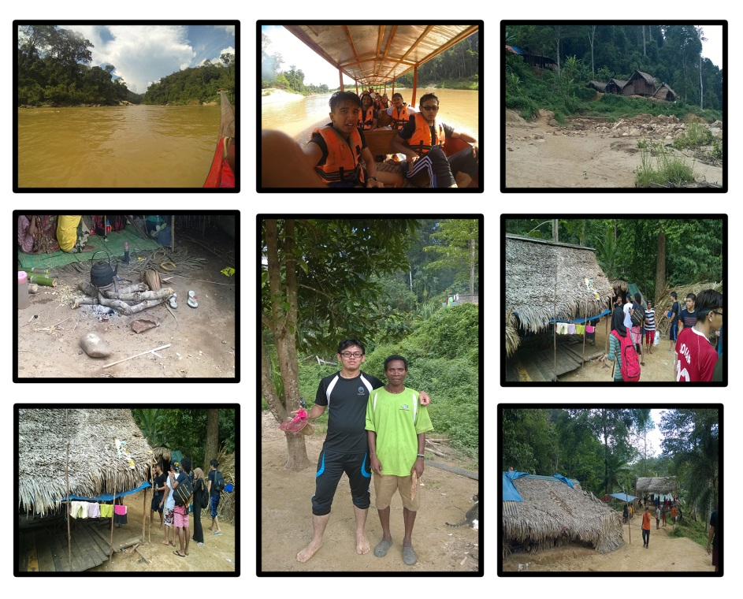

Based on the experience at National Park, I can conclude that we as humans play an important role to ensure the balance of the ecosystem in our country. The national park shows us how they can organize a lot of activities without affecting the nature. For example, during the jungle night walk and jungle trekking activities, the wooden pathway were used without disturbing any single trees. As what I observed was, the path was built in not a straight path to avoid some trees. This is one of the examples how we can connect with the nature in a correct way. So, we do not have to chop down the trees if we want to walk inside the forest. It also makes the tourists easier to walk around. From the night jungle walk activity, I saw many types of insects which most of them are nocturnal insect. There are one and only thing that I can conclude here which is the balance of the ecosystem. That is why I could saw the nocturnal insects came out at night to find some food because they know they could get it there. From the jungle trekking activity, I also know many types of plants and animals that I had never seen before. Some of them are useful to the animals and also the indigenous people. This shows how exactly the human, nature and animals are connecting to each other. The plants absorb the sunlight and produce the food to human and animals. Some of them can be used as medicine to the human. As I arriveed to the *orang asli*’s settlement, I could see how they worked as a community based on their tradition. The Batek’s lifestyle showed me on how they managed to fully use the nature to ensure their continuity of life. Their lifestyle such as hunting and gathering show us that they play an important role in the ecosystem. They also can adapt to their environment easily because of their knowledge about the place.